“ ЗАТВЕРДЖЕНО”
на методичній нараді кафедри
дитячої хірургії протокол № 1
від 10 січня 2018 року
Зав. кафедрою дитячої хірургії
професор_______________А.Ф. Левицький

Theme No 5.

Purulent infections of soft tissues in children. Necrotic phlegmon of newborn, mastitis, omphalitis, lymphadenitis, adenophlegmon. Pararectal abscess (Paraproctitis). Etiology, pathogenesis, classification, diagnosis, treatment. Postoperative management.
Acute haematogenic osteomyelitis. Ostomyelitis in newborn, atypical forms of osteomyelitis. Etiopathogenesis, clinical prtesentations, peculiarities of diagnostics, principles of treatment, prevention of complicaions. Clinical examination. BCG- osteitis. Sepsis

Compiler:
Professor’s assistant of pediatric surgery department, PhD Vityaz Vladimir

Theme Overview:

Bone and joint infections are a significant cause of morbidity in infants and young children. Although many principles regarding pathogenesis, diagnosis, and treatment of infection have remained constant over the years, other aspects of this important pediatric diagnosis are continuing to evolve. A large proportion of these diseases, their complications and consequences that lead to disability in childhood, determines the relevance of the topic

Educational aims

1. Internalize the list of pyo-inflammatory diseases of bones and joints in children.
2. Recognize the etiology of pyo-inflammatory diseases of the bones and joints.
3. Differentiate purulent-inflammatory diseases of bones, joints and soft tissues depending on the localization and the reasons of occurrence.
4. Interpret the auxiliary research methods: ultrasound, x-ray, laboratory and biochemical tests, performance of hemodynamics.
5. Demonstrate the technique of puncture joints, dissection of the abscesses.
6. Identify the features of the course of pyo-inflammatory diseases of the bones, joints and soft tissues.
7. To substantiate and to formulate preliminary clinical diagnosis.
8. Suggest the algorithm of the physician's actions at pyo-inflammatory diseases of bones, joints and soft tissues, the tactics of the patient.
9. Interpret the general principles of treatment of pyo-inflammatory diseases of the bones, joints and soft tissue, determine the indications for surgical treatment.

A student must know

1. What is the periodicity of purulent-septic diseases, their structure and main causes of arising?
2. What are the anatomical and physiological peculiarities of the structure of the skin and subcutaneous tissue facilitate the spread of inflammatory process?
3. Name the clinical manifestations of phlegmon.
4. Therapeutic tactics at phlegmon.
5. Forms and clinical manifestations of abscesses.
6. The features of the treatment of abscesses.
7. When and with what the lymphadenopathy is associated?
8. Particularities of surgical intervention at lymphadenitis.
9. Courses of treatment of purulent-septic diseases.
10. What is the basis of the empirical approach to antibiotic prescribing?
11. Bacteriological research at purulent-septic diseases. How to perform it?
12. Name the components of the medical effects on the child body having purulent-septic diseases. What it depends from?
13. What is the syndrome of systemic inflammatory response?
14. What are the components of a toxic form of the disease, according to the international classification of sepsis?
15. What is the circulation of bone segments in children of different ages?
16. Why in newborns and children up to 2 years old meta-epiphyseal occurs?
17. Features of joint puncture in newborns. How often is this performed?
18. Features of immobilization and its duration in children with hematogenous osteomyelitis.
19. Name the complications that are associated with the hematogenous osteomyelitis. When they appear?

A student must be able to:

1.To collect the complaints, anamnesis of disease and life at the pediatric patient and his (her) parents at the patient with purulent infections.
2.To demonstrate the examination, percussion and palpation of the abdominal wall and make a plan of following examination of the patient with purulent infections
3.To perform differential diagnosis of purulent-septic diseases in children.
4.To interpret X- ray films in purulent-septic diseases.
6.To know indications for the operative treatment of purulent-septic diseases.
7. To demonstrate the technique of bones and joints puncture in children with purulent-septic diseases.
8. To determine main methods of treatment of purulent-septic diseases in children.

Terminology

# | Term | Definition
1. | Acute hematogenous osteomyelitis | Septic infection disease of the bones, which develops on the background of changes in macroorganism reactivity associated with the process of growth, and is accompanied by significant violation of homeostasis
2. | Lymphadenitis | purulent inflammation of lymph nodes
3. | Adenophlegmon | Purulent inflammation of lymph nodes with subcutaneous tissue
4. | Abscess | purulent inflammation of the soft tissues, separated from the surrounding tissue by capsule
5. | Phlegmon | purulent inflammation of soft tissue that has no clear boundaries

Necrotic phlegmon of newborn.
Among the suppurative inflammatory diseases of the newborn the phlegmon that occurs in the first weeks of life has an important place.
Newborn phlegmon is a severe necrotic skin and subcutaneous adipose tissue disease, characterized by the rapid development of the pathological process with the transition to necrosis. The author of the term "newborn phlegmon" is SA Vasiliev (SY Doletsky, JF Isakov, 1970). The occurrence of the disease is due to anatomical and physiological characteristics of the structure of the skin and subcutaneous fat in the newborn. a newborn baby's skin is thin and delicate, the surface layer consists of 2-3 rows of dead skin cells that are easy peeled off. Sweat glands are developed normally, but their function is reduced. Subcutaneous adipose tissue consists mainly of loose tissue, connective tissue septa are underdeveloped (except for palmar and plantar surfaces of the hands and feet, where the phlegmon does not occur). Its chemical composition is dominated by a solid fatty acids (palmitic, stearic, etc.), resulting in a hardening, especially when supercooling. The blood supply of the skin is carried out on the main vessels that have an insufficient number of branches in the subcutaneous adipose tissue. The barrier function of the skin is not perfect.
Etiology. The etiological factor of newborns phlegmon are Gram-positive, Gram-negative, anaerobic microorganisms. Ways of their penetration may be different. Most of pediatric surgeons estimate the minor damage of the thin, delicate skin as the most likely gateway of infection. Hematogenous and lymphogenous pathways are not excluded (omphalitis, umbilical sepsis, etc.). In pus inoculations at necrotic phlegmon the gram-positive microflora is detected more often, gram-negative is uncommon. Severe disease is observed in the presence of Gram-positive and Gram-negative association of microorganisms.
Pathogenesis. In treatment of the pathogenesis of neonatal necrotizing phlegmon is necessary to consider the state of the microorganism. According to our data, phlegmon affects mainly premature infants injured during birth. The state of health of the mother is very important. The frequent incidence of neonatal phlegmon within 5- 15 th day after the birth suggests in its favor, when the antibodies derived from the mother's are exhausted, and one’s own still have not worked out. The proof of this is the high mortality rate among newborns, patients with phlegmon in the first 5 days of life. There is no doubt that the virulence of microorganisms is also of great importance.
The pathological process occurs in the tissues around the sweat glands, extending along the lymphatic vessels and fissures. Blood vessels due to violations of local microcirculation are thrombosed. The endo- and periarteritis arise with fibrin exudation in which bacteria are accumulated, sometimes they fill up the lumens of blood vessels. It should be noted that the necrotic process of the subcutaneous adipose tissue can spread to nearby tissues up to the superficial fascia with almost no inflammatory reaction, which is due to anatomical and physiological characteristics of blood supply of the subcutaneous fat.
Process is propagated very fast. By the end of second, and sometimes by the 1st day in the skin of initially affected area softening zone with distinct fluctuation appears, but even in this period is not always possible to get a purulent exudate. In the depth of the wound subcutaneous fat of dirty-gray color reveals. The skin in the affected area gradually becomes purple-bluish, dark gray. There is a rejection of necrotic tissues down to the muscles, tendons, bones sometimes. According to our data, necrotic phlegmon develops very quickly.
The clinical picture. There are toxicoseptic (occurs more often) and simple (localized) forms. Toxicoseptic form has an acute onset with rapid development of intoxication. At the beginning of the disease general condition is worsened, body temperature rises rapidly, the vomiting often occurs. The child is restless, refuses the breast, gradually weakens. The skin is gray or of marble tint. Tongue is dry, coated. Muffled heart sounds, pulse is frequent. In the blood there are signs of anemia, leukocytosis, leukocyte formula shifts to the left. The child's condition without appropriate treatment is rapidly deteriorated. The body temperature remains high, the signs of intoxication are growing. The child does not respond to others, adynamic; the multiple vomiting, diarrhea, no appetite are observed. The exsicosis develops, the body weight decreases. At this period the development of secondary multiple foci of suppuration (pneumonia, peritonitis, otitis, and so on), metastasis are possible.
Simple (localized) form is much rarer. It is characterized by the gradual onset. The body temperature rises to 37,2-38°C, no appetite. Skin and mucous membranes are pale. From the first hours of the disease the child is restless, especially during diaper changing and shifting. General symptoms develop less intensive than local. In case of irrational therapy, the disease progresses fast. General condition becomes worse, signs of intoxication, dehydration and anemia grow.
The local symptoms in both forms of necrotizing phlegmon develope almost identically. Firstly, on the skin of the lumbar region or the back, the anterior chest and abdominal walls, buttocks, neck, head (much less - the skin of limbs) the focus of hyperemia of small size arises. After 5-8 hours, it increases, there is a slight swelling and induration. By the end of the 1st day from the beginning of the disease the hyperemia covers a significant surface of the skin, its edges are indistinct. Palpation in the core of the center reveals a gentle recess, in 2-3 day at this point the cyanosis appears. On the 5-7 th day the skin becomes macerated, thinning – this is the period of disease progression (FI Kainov, 1973). There is a rapid rejection of necrotic tissues, wound defect is formed out. On the 10-15th day from the beginning of the disease necrotic tissues are completely rejected, inflammatory symptoms subside, the granulation is formed in the wound. The wound epithelization occurs at different terms, depending on the wound defect size and general condition of the child. If the wound dimensions are larger than 5 cm in diameter, it is necessary to perform skin grafting.
The differential diagnosis in the early stages of necrotic phlegmon is carried out with erythematous form of erysipelas. Common symptoms of necrotizing phlegmon and erysipelas are: acute onset, fever, pallor of the unaffected skin, signs of intoxication (vomiting, tachycardia). The changes in the blood are tipicals (mild anemia, leukocytosis, leukocyte formula shifts to the left).
In the case of erysipelas the skin redness in the area of damage has well-defined contours (resembling flames), skin is tense, lustrous. At the boundary with the healthy tissue by palpation the skin edema line is detected that dominates the healthy skin. In case of necrotic phlegmon in the center of congestion the recess is often detected. The erysipelas is localized mostly on the face, in the paraumbilical region, on the lower extremities. Such localization is not typical for necrotizing phlegmon.
The simple form of necrotizing phlegmon is sometimes necessary to differentiate from sclerema (scleredema) of newborns. Sclerema as well as the phlegmon, more often occurs in preterm infants due to hypothermia and is not accompanied by inflammatory symptoms. The induration of subcutaneous fat in the form of various sized portions is typical for sclerema. At the same time the skin is dry, dense, cold to the touch. The body temperature is lowered, or normal, in contrast to the fever of newborns phlegmon.
Subcutaneous adiponecrosis of newborns is characterized by the gradual formation in the subcutaneous adipose tissue of multiple small-sized infiltrates which are painless during palpation. In children with adiponekrosis history there is evidence of injury during birth, asphyxia, neonatal resuscitation. As a rule, children suffer whose weight after birth was more than 3500 g. The infiltrates may merge, the flushing of the skin is possible. In contrast to newborn phlegmon the child's general condition is unchanged, body temperature is normal. Appetite is saved, the child is gaining weight. Recovery occurs within 5-6 weeks.
Treatment of necrotizing newborn phlegmon is only surgery. After diagnose is done the child is urgently hospitalized in the surgical department. Therapeutic measures are directed to sanitization of the source of inflammation, to increase the body defenses and to fight the infection.
At the initial stage of newborns phlegmon one has to determine the focus borders. For this purpose, the skin is treated with a cotton ball wetted in a solution of 70% ethanol. Vessels of unaffected skin under the influence of alcohol evaporation are in spasm, skin becomes pale, the boundary becomes clear, it is marked by a solution of brilliant green. This helps during surgery and to further control of the spread of the pathological process. The inflammatory infiltrate is injected around along the border of 0.25% solution of lidocaine or novocaine with antibiotic (daily dose) at several points. After blockade one performs multiple incisions staggered along the entire length of the inflammatory focus 1 - 1.5 cm long with the distance between 1-2 cm. They have to get out of the inflammation limits at 0.5 - 1.0 cm (Fig. 4.2). The wounds are drained by the rubber strips. Bandage with a hypertonic solution of sodium chloride or magnesium sulfate is applied on the wound.
The wound is redressed in 4-6 hours after the operation to control the spread of the inflammatory process. If it spreads out of the specified boundaries the additional cuts are applied, if it misses - the bandage changing has to be done. After one day drains are removed, purulent wounds are being treated. Surgery can be performed both under general or local anesthesia.
At the same time a detoxication therapy (gastric lavage at vomiting, intravenous introduction of 5% glucose solution with insulin, Ringer's solution to the age-dose) is carried out. A fresh frozen or native plasma, an intravenous immunoglobulin have to be transfused. In severe anemia transfusions of packed red blood cells is prescribed. Antibiotic therapy is chosen at the beginning and performed until the results of microbiological examination and antibiogram are received. In recent years, the number of patients with necrotizing phlegmon is significantly decreased as well as the mortality.
Neonatal Mastitis
Mastitis in the newborn period mostly affects term or near-term infants, and females more often than males. Staphylococcus represents the causative organism in nearly all cases, but occasionally infections with Escherichia coli, Salmonella, Shigella, and Klebsiella have been described. Clinically, the breast shows the typical signs of infection with induration, swelling, occasional fluctuation, and excretion of pus. The therapy consists of immediate intravenous application of appropriate antibiotics. Small abscesses can be needle aspirated with ultrasonographic guidance. In cases with relevant fl uctuance, incision and drainage is required. A decrease in breast size compared to the opposite side has been reported from a small series of adolescents who had undergone former drainage of a breast abscess. Therefore, the periareolar incision should be limited and can be placed radially to minimize lesion of the ducts. Breast abscess in the female adolescent is rare and may be attributed to nonpuerperal mastitis on infection of an epidermal cyst.
Umbilical Infections
Although modern perinatal practice has dramatically reducedthe incidence of omphalitis, infections of the umbilicus still occur with alarming morbidity and mortality, particularly inundeveloped countries. Rigorous asepsis, hand washing, and cord care (either dry cord care or topical antimicrobials) have reduced the incidence of umbilical infections to less than 1% in hospitalized newborns. Before the institution of such practices, the mortality rate for omphalitis was 65%. The primary pathogens implicated in these infections were Staphylococcus aureus and Streptococcus pyogenes. Currently, gram-negative bacteria play an important role in the pathogenesis of umbilical infections. Severe infections are often polymicrobial. Omphalitis may be manifested as a purulent umbilical discharge or periumbilical cellulitis. Delivery at home, low birth weight, use of umbilical catheters, and septic delivery are risk factors. Tetanus infection occurs on rare occasions. Intravenous antibiotic therapy is effective in eradicating most infections. Omphalitis is a common problem in developing countries, where it accounts for more than a quarter of neonatal hospital admissions. Cellulitis may progress to fasciitis, and such progression may be subtle. Signs of necrotizing fasciitis include abdominal distention, tachycardia, purpura, blistering, pyrexia, hypothermia, leukocytosis, and progression of cellulitis despite antibiotic therapy. Bacteriologic cultures demonstrate polymicrobial flora. Necrotizing fasciitis and umbilical gangrene may be lethal and require immediate wide surgical debridement for patient survival. Excision should be performed immediately on recognition; all infected skin, fat, and fascia should be excised back to viable, bleeding abdominal wall musculature. The umbilicus is obligatorily excised. Excision of preperitoneal tissue including the umbilical vessels and urachal remnant may be critically important to achieve eradication of the infection because these tissues harbor invasive bacteria and may provide a route for the progressive spread of infection seen after less extensive surgical debridement. The defect may require a temporary prosthetic patch for closure, but ultimate fascial closure and umbilical reconstruction may leave an acceptable appearance. Hyperbaric oxygen therapy has been advocated as adjuvant therapy, but it is not of proven benefit. The overall reported mortality associated with necrotizing fasciitis in collected series is 81%. Umbilical drainage resulting from chronic infection of umbilical remnants such as umbilical artery remnants has also been reported. Excision and debridement are curative. Omphalitis can result in necrosis and breakdown of the umbilical stump with spontaneous evisceration within the first 2 months of life and may be associated with portal venous thrombosis and subsequent extrahepatic portal hypertension.
Lymphadenitis
Lymphadenitis is an inflammation of the lymph nodes. Among the purulent surgical diseases in children, it takes one of the leading places. It is considered as an evidence of the barrier function of the lymphatic system and the limiting of the spread of the infectious agent and its toxins as a result. Sometimes lymphadenitis may be the cause of purulent and septic process. YF Isakov and SY Doletsky (1970) pointed out the role of the body sensitization after suffering a suppurative disease.
Clinical features of lymphadenitis in children are due to anatomical and physiological characteristics of the lymph nodes and lymphatic system.
In recent years, the incidence rate has increased due to the increase of the antigenic effect on the child's body, weakening the respective immune responses, most of which occur in the inflammation focus and the regional lymph nodes.
Etiology and pathogenesis. The disease has predominantly a secondary character. The infection penetrates in the lymph nodes through the lymphogenous, sometimes - hematogenous route.
The cause of acute lymphadenitis may be focuses of festering of different localization, purulent inflammatory diseases of the chest and abdomen, pelvic, abscess after surgery, as well as furunculosis, abscesses, phlegmon, infected abrasions, insect and animal’s bites, complications of parotitis, tonsillitis, dental caries and so on. Some patients may have a festering focus of small size, which makes it harder to detect. The causative agent of acute lymphadenitis mostly is Staphylococcus aureus. The toxoplasmosis and CMV infection also play the possible role in its appearance.
The progress of acute lymphadenitis is highly depended from the overall condition of the body at the time of the pathogen infection. Most immune responses occur in inflammation focus and in the regional lymph nodes, causing hyperplasia and an increase of the lymphoid tissue, and lymphadenopathy. If the immune response in lymph nodes is insufficient, then the inflammatory response occurs directly into the lymph nodes and vessels, which are clinical signs of lymphangitis and lymphadenitis.
Classification. There are two clinical forms of lymphadenitis - acute and chronic. In its turn, acute lymphadenitis is divided into:
• simple (serous, catarrhal);
• abscessed, or purulent inflammation;
• phlegmonous adenitis.
Inflammation may occur in lymph nodes of different localization. According to our data, most often affected nodes are mandibular, and cervical lymph nodes, then - axillary and inguinal, and occasionaly - iliac. Phlegmonous adenitis often occurs in lesions of the external and internal iliac lymph nodes, which accumulate in the lymph coming from the lower limbs, abdomen, pelvic organs, externalia, anus.
The clinical presentation. The inflammatory process mostly progresses as the serous type. Pain and swollen lymph nodes are observed. First, the node is mobile with smooth surface, the skin over and around it is almost not changed, later it becomes edematous, hyperemic. The child's condition is satisfactory, the body temperature of low-grade. Catarrhal form of lymphadenitis may be complicated by a purulent inflammation and necrosis of the lymph node, which is accompanied by a deterioration of general condition, increasing of body temperature to high numbers and the emergence of local clinical signs of purulent inflammation - redness, local temperature reactions and fluctuations. Tissues are infiltrated. Movement and palpation in the affected area are causing pain. If you do not start treatment, the inflammatory process extends to the nearby lymph nodes and soft tissues and the phlegmonous adenitis develops. The gangrenous form of lymphadenitis occurs very rarely in children.
Sometimes acute lymphadenitis progresses atypically, some authors attribute it to the chronic form with a long history. It is caused by irrational antibiotic therapy of catarrhal form of lymphadenitis. The primary focus of inflammation can not be determined, though the lymph nodes remain enlarged for a long time.
The general condition of the child is changed a little, the body temperature is not raised. A blood test is without changes.
Diagnosis and differential diagnosis. Diagnosis of typical course of lymphadenitis is mostly simple. Purulent inflammation of the lymph nodes of iliac region needs to be differentiated from a strangulated hernia, osteomyelitis of the pelvis, hip joint inflammation, acute appendicitis.
I.V. Potebnya et al (2012) recommend to carry out the ultrasound with echomorphology of lymph nodes assessment to all patients who complain on swelling of the lymph nodes or the clinical manifestations of acute lymphadenitis. Ultrasound allows to track the stage of inflammation of the lymph nodes and the dynamics of recovery after treatment. The developed diagnostic and treatment algorithm helps to more accurately and promptly determine the stage of purulent lymphadenitis, to plan tactics of surgical treatment, to determine the indications for conservative treatment The sonographic criteria for lymph node inflammation stages (heterogeneity of structure, the appearance of the liquid clusters, destruction foci) are revealed, which significantly improves the results of traditional diagnostic methods (sensitivity - 97.6%, specificity - 91.1%, accuracy - 97.2%).
Differential diagnosis of specific lymphadenitis, hyperplastic or lymphoproliferative lymphadenopathy is complicated.
Specific pathological process in tuberculosis, mononucleosis, toxoplasmosis, blood diseases, malignant lymphoma requires ultrasound, deployed hemogram, serological diagnosis, immunotesting, radiography of the chest cavity, diagnostic puncture and cytology, and sometimes histological verification.
Treatment of acute lymphadenitis depends on the form of the disease, the localization process, the age and general condition of the patient. When catarrhal form the broad-spectrum antibiotics, antisensitazers, acetylsalicylic acid; locally - tube-quartz, UHF, bandages with dimexidum are prescribed.
If conservative treatment of acute catarrhal lymphadenitis was ineffective, after cytological confirmation of inflammation, antibiotic therapy, physical therapy, the patients require observation of the surgeon during 1-2 months. If the lymph node is not reduced, under general anesthesia its enucleation with histological confirmation of the diagnosis is performed. In the case of suppurative lymphadenitis after diagnostic puncture and pus detection the surgery is performed: festering focus opening with cavity drainage by the rubber strip.
The first 2 days for reducing soft tissue swelling the bandage with 10% sodium chloride solution or 25% magnesium sulfate solution is applied. In children under 1 year old, the concentration of hypertonic solutions is reduced by half.
Under antibiotic therapy, desensitizing and vitamin therapy in the case of persistent edema magnetic laser or laser therapy is prescribed. In uncomplicated forms of acute lymphadenitis final recovery with wound healing occurs in the 7-10-th day.
Phlegmonous adenitis requires surgery under general anesthesia. On the border of the spread of pus several incisions are made through which the cavity is drained. The complex treatment includes detoxifying and antibacterial therapy, physiotherapy and so on.
Prognosis of the external purulent lymphadenitis with prompt treatment is favorable. If purulent process extends beyond the lymph nodes with the development of phlegmonous adenitis, the prognosis becomes more complicated, so the therapeutic tactics must be operational.
Paraproctitis (pararectal abscess)
Pyo-inflammatory process, localized in the subcutaneous adipose tissue around the anus is called paraproctitis or peri anal abscess. According to our data, recently its rate in relation to all purulent-inflammatory diseases of the newborn is 6.7%.
Etiology. The development of the inflammatory process cause microtrauma of the mucous membrane of the rectum, skin diseases in the area of the perineum and anus (maceration, fissures), and the presence of congenital adrectal fistulas and long saccular crypts. The causes of microtraumas of rectal mucous membrane are constipation and diarrhea. The anal (Morgagni’s) crypts retain dejection, pieces of undigested food, which injure the mucous membrane. With diarrhea, especially with frequent tenesmus, dense parts of feces injure the anal crypt. Significant rectum stretch by the dejection may lead to the formation of microfissures. The important point for the development of paraproctitis is to increase the tone of the external sphincter of the anus. Very rarely the mucosal damage by enema tip, foreign bodies, and others is observed. Sometimes paraproctitis occurs at presence of congenital pararectal fistula, which causes relapsing course of the disease. Most often this pathology is diagnosed in boys. The important role in the inflammatory process development belongs to the immunodeficiency state. (G. Khanes, V. Marsakova et al., 2006).
The clinical picture of perianal abscess depends on the localization of the foci. Possible options for its location are shown in Fig. 4.3. Ulcer can be located under the skin, under the mucosa, in pelvic-rectal tissue, behind the rectum (retrorectal localization) and in ischiorektal area.
At the newborn the subcutaneous abscesses are mainly developed.
Disease begins acutely. Body temperature rises to 38-39°C. The child is restless, especially during the act of defecation, which can be sharply painful if the abscess is localized under the mucous membrane. There is a delay of urination and stool.
Local changes in acute paraproctitis and subcutaneous abscess localization are characterized by swelling, skin hyperemia and fluctuation. The swelling is painful at palpation. With these features the diagnosis is beyond doubt.
Treatment. The only method of treatment of purulent paraproctitis in neonates is an operation. Under general or local anesthesia (0.5% solution novocaine, 1% lidocaine) the abscess puncture is performed by a thick needle. If pus is obtained, radial or semioval incision is performed, but always with a skin excision above the abscess (the wound has to be gaped) and with binding excision of the crypt. The wound is washed with 3% hydrogen peroxide solution or other antiseptic and drained by a rubber strip. An aseptic bandage is imposed until the first defecation. The wound is kept open, but it required a careful toilet after each act of defecation and urination. A local quartz irradiation is prescribed, UHF. An antibacterial therapy is carried out.
Prognosis. The transition of acute abscess in the chronic stage in the newborn is very rare.
The method of choice in the treatment of acute paraproctitis is a radical surgery: an excision of the fistula channel and the elimination of communication with the rectum, which is most appropriate to be done at the same time. A method of operation is selected individually, taking into account the relation of the fistulous sphincter to the rectum. The application of the tactics and methods of treatment of chronic paraproctitis in children of all age groups allows for recovery in 99% of cases, and this gives grounds to recommend them for widespread use in the practice of pediatric surgery.
Osteomyelitis
Osteomyelitis is inflammation of the bone caused by infection with bacterial or fungal organisms. Osteomyelitis often is categorized into three different types:
(1) acute hematogenous osteomyelitis; (2) osteomyelitis secondary to contiguous spread of infection after trauma, puncture wounds, surgery, or joint replacement; and (3) osteomyelitis secondary to vascular insufficiency. Acute hematogenous osteomyelitis is seen most often in children. Osteomyelitis caused by contiguous spread of infection is less common in children, and infection secondary to vascular insufficiency is rare in children.
Pathogenesis. Acute hematogenous osteomyelitis results from symptomatic or asymptomatic bacteremia. Because of its rich vascular supply, the metaphysis of the bone is most often involved. The infecting organism travels to metaphyseal capillary loops, where it replicates and causes local inflammation. As the bacteria replicate, they travel through vascular tunnels and adhere to cartilaginous matrix. Staphylococcus aureus is the most common cause of infection perhaps because of its capacity to express bacterial adhesions that promote attachment to extra- cellular bone matrix. This organism also is able to evade host defenses, attack host cells, and colonize bone persistently.
The bony metaphyses of children younger than 18 months are vascularized by the transphyseal vessels. Because these vessels enter the epiphysis and ultimately the joint space, young children are believed to have a higher risk of joint space infection complicating osteomyelitis. One clinical study found the incidence of adjacent joint involvement to be the same, however, in children older than 18 months compared with children younger than 18 months. The authors speculated that some cases of joint involvement could be due to subperiosteal spread of infection into the joint space or that an adjacent site of osteomyelitis may predispose an adjacent joint to hematogenous seeding.
Animal models show that bone infection is more likely after bacteremic animals sustain trauma to the affected area. These animal models may explain why a history of trauma is elicited in approximately 30% children before onset of symptoms. Contiguous osteomyelitis in children is seen in the setting of trauma; animal bites; puncture wounds; and direct extension of infection from an infected sinus, mastoid bone, or dental abscess.

Epidemiology. Approximately 50% of cases of osteomyelitis occur in the first 5 years of life. Boys are more likely than girls to be affected. The long bones of the lower extremities are most often involved, although any bone may be affected.

Microbiology. The type of infecting organism depends on the age of the child and underlying medical problem. S. aureus is the most common cause of osteomyelitis in all age groups, accounting for 70% to 90% of infections. Infection caused by methicillin-resistant S. aureus (MRSA) is becoming an increasingly common problem. One group of investigators identified 59 patients with musculoskeletal infections caused by S. aureus over a 2-year period at their center. More than half of the patients described were infected with community-acquired MRSA (CA-MRSA).
In addition to S. aureus, young infants may develop osteomyelitis caused by Streptococcus agalactiae or enteric gram-negative bacteria. Organisms other than S. aureus causing infection in older children include Streptococcus pyogenes, Streptococcus pneumoniae, and Kingella kingae. S. pyogenes causes approximately 10% of cases of acute hematogenous osteomyelitis with a peak incidence of disease in preschool-age and early school–age children. Children with S. pyogenes osteomyelitis often have a recent history of varicella infection and present with higher fever and white blood cell (WBC) counts compared with children infected with S. aureus.
Children with osteomyelitis caused by S. pneumoniae are younger than chil- dren infected with S. aureus and S. pyogenes. They are more likely to have joint involvement. The proportion of bone infections caused by S. pneumoniae is relatively small (approximately 1–4%); the impact of heptavalent pneumococcal conjugate vaccine on the incidence of osteomyelitis is limited.
K. kingae is reported as a pathogen with increasing frequency. A cluster of bone and joint infections caused by K. kingae at a daycare center underscores the importance of this organism in children with musculoskeletal infections.
K. kingae is a fastidious gram-negative coccobacillary bacterium found in normal respiratory flora. Infection with this organism often is preceded by an upper respiratory tract infection or stomatitis; disrupted respiratory mucosa may facilitate invasion and hematogenous dissemination.
There has been a substantial decrease in musculoskeletal infections secondary to Haemophilus influenzae type b (Hib) as a result of an effective immunization program against this pathogen. Hib infection is rare in a completely immunized child, although other serotypes are reported to cause bone and joint infections.
Puncture wounds to the foot may result in osteomyelitis caused by mixed flora, including Pseudomonas, S. aureus, enteric gram-negative bacteria, and anaerobes. The source of bacteria is usually from moist colonized soles of tennis shoes. A series of cases describes osteomyelitis of the metatarsals occurring as a result of toothpick puncture injuries. The organisms isolated included skin and environmental organisms; others have reported infection with mouth organisms as a result of toothpick injuries.
Anaerobes are a rare cause of pyogenic osteomyelitis in healthy children. Predominant organisms are Bacteroides, Fusobacterium, Clostridium, and Pepto-streptococcus. Anaerobic osteomyelitis can occur as the result of a bite, chronic sinusitis, mastoiditis, or dental infection.
Organisms causing bone infection in children with sickle cell disease include Salmonella and S. aureus and less commonly Escherichia coli, Hib, Shigella, and S. pneumoniae. Unusual causes of osteomyelitis include infection with Mycobacterium, Bartonella, Coxiella burnetii, or fungi. The specific etiology of osteomyelitis is not determined in many cases; nonetheless, resolution after empirical therapy for S. aureus is usual.
Clinical manifestations. Most children with acute hematogenous osteomyelitis are symptomatic for less than 2 weeks. Symptoms include complaints of acute, persistent, and increasing pain over the affected bone. Osteomyelitis in an infant may present as irritability or reluctance to move the affected limb. Fever is usually present. Swelling or redness of the soft tissue over the affected bone may be seen. In one study, patients with culture-positive osteomyelitis were more likely than patients with culture-negative osteomyelitis to have a history of antecedent trauma, changes in skin overlying the bone, associated cellulites, or high fever.

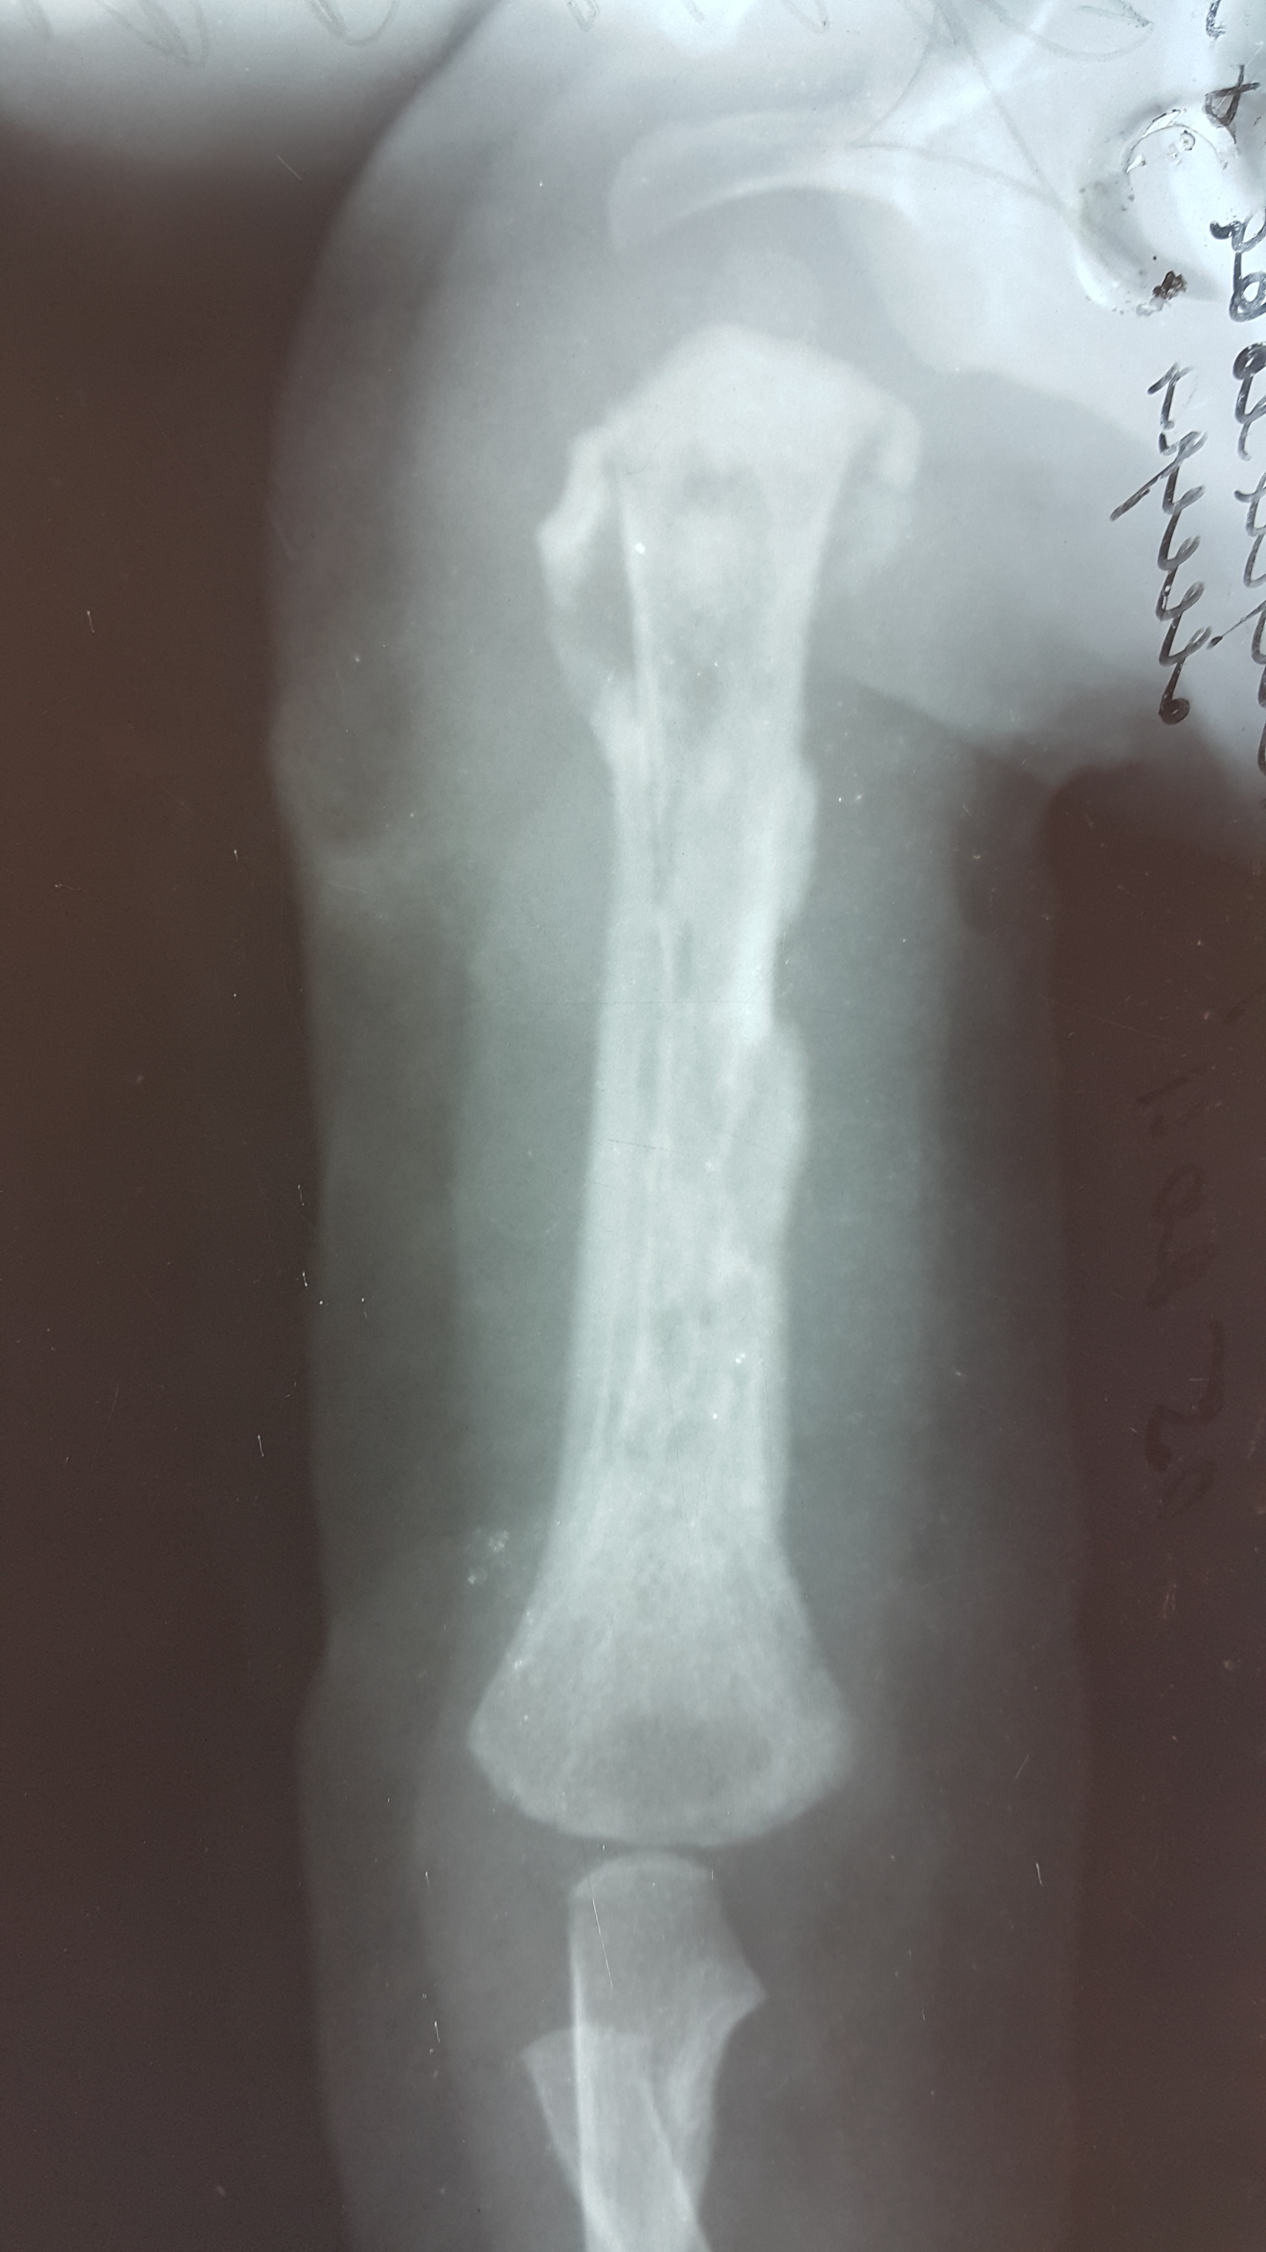
Pic.1 Periostitis of the humerus in the later stages of acute osteomyelitis
Pelvic osteomyelitis is reported in 1% to 11% of all cases of acute hematogenous osteomyelitis and typically affects older children. Symptoms include hip, buttock, low back, or abdominal pain. Fever may be absent. Findings on physical examination include tenderness of the pelvic bones, pain with hip movement, decreased range of motion at the hip, and refusal or inability to bear weight. Any bone in the pelvis may be involved, but the ilium tends to be affected most often, presumably because of its rich blood supply. Symptoms and findings frequently are nonspecific and poorly localized and often are attributed to other diagnoses, such as pyogenic arthritis of the hip or appendicitis. Establishing the correct diagnosis often is delayed.
Subacute osteomyelitis is a distinct form of osteomyelitis, and Brodie abscess is one type of subacute osteomyelitis. Subacute osteomyelitis is difficult to diagnose because the characteristic signs and symptoms of the acute form of the disease are absent. The disease has an insidious onset, mild symptoms, and lacks a systemic reaction, and supportive laboratory data are inconsistent. Subacute osteomyelitis may mimic various benign and malignant conditions, resulting in delayed diagnosis and treatment. The most frequently made incorrect diagnosis is that of tumor.
I.S. Venguerovskiy (1964) determined: local diffuse osteomyelitis, sclerotic osteomyelitis, albuminous osteomyelitis and intraosseous abscess (Brodi). S. Popkirov (1974) added antibiotic osteomyelitis into this classification.
Each form has its own localization and peculiar X-ray picture.
Local diffuse osteomyelitis is localized in short and flat bones and in long tubular bones. Roentgenological picture is characterized by numerous foci of osteolysis and absent periostal reaction in the beginning of the disease. The characteristic mosaic structure of destruction appears in 1-2 months.
Sclerosing osteomyelitis is also called a new bone. These are diaphysis and metaphysis of the femur and tibia that affected most frequently. The clinical signs are a bone thickening and a hardening of muscular tissues. The roentgenological peculiarities of this pathology are sudden constriction of the medullary canal or its obliteration, bone thickening after dense homogenous sclerosis, sometimes there are foci of destruction with small sequesters.
Albuminous osteomyelitis — is a rare disease that is characterizedat the beginning by feeling of discomfort in the extremity, then- continuous pain, appears in 1-2 months there appear swelling, sometimes hyperemia. Local temperature reaction is usually slight. The most frequent localization is a distal metaphysis of the femur or proximal metaphisis of the tibia. X-ray shows cavity of irregular shape or circular cavity with periostal layers. The diagnosis may be easily confirmed by puncture of the focus of an albuminous fluid is obtained. Histological examination of the focus determine a plasmic-cellular granulation tissue (Russell’s body).
Abscess of Brodi is localized in metaphyses of long tubular bones (femur, tibia). It is characterized by limb dysfunctioning, pain in the focal area, nocturnal pain, swelling, frequently with arthritis. Roentgenological picture shows oval or circular cavity with sclerotizing capsule, it may include sequesters and is situated on the border of metaphysis and epiphysis.
Antibiotic osteomyelitis is a consequence of wrong antibiotic treatment of acute haematogenous osteomyelitis that just delays the disease development.
In noncontemporary literature, Brodie abscess was referred to as a chronic form of osteomyelitis; however, in almost all contemporary literature references, Brodie abscess is referred to as the most common type of the subacute form of osteomyelitis.
The differential diagnosis of bone pain in children includes trauma, malignancy, and bone infarction in patients with sickle cell disease. Differentiation between bone infection and infarction in a child with sickle cell anemia is difficult because in both cases the acute onset of fever and bone pain is common. In addition, a patient may have infarction that predisposes to infection.
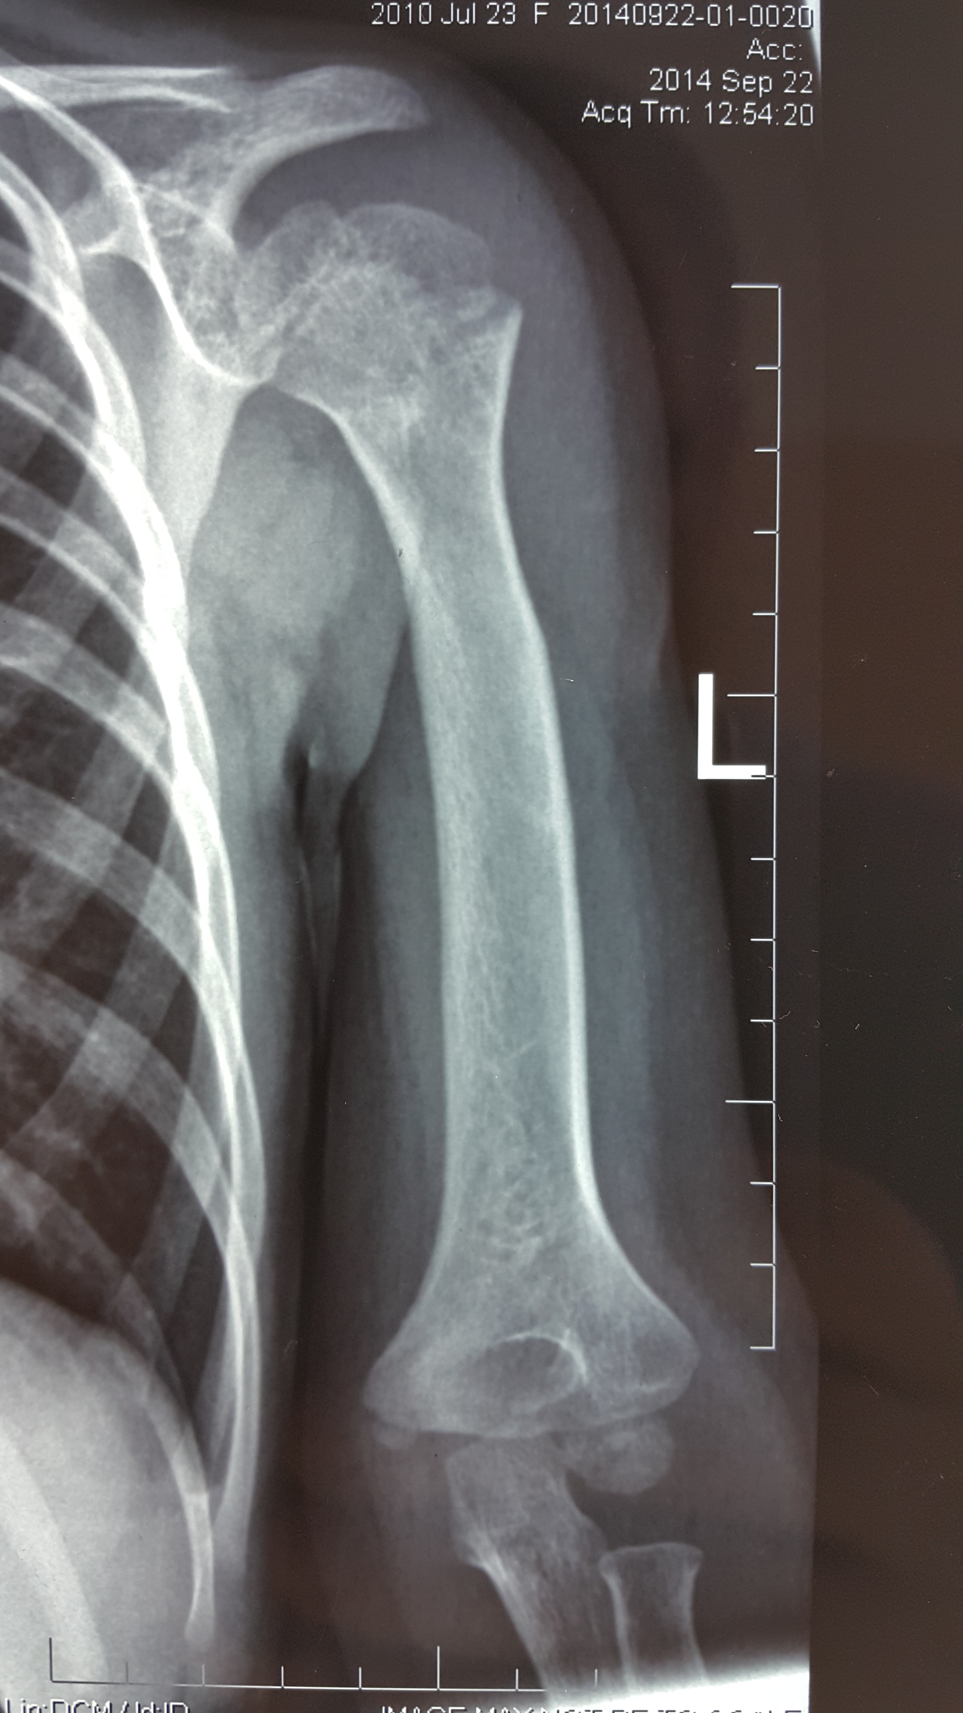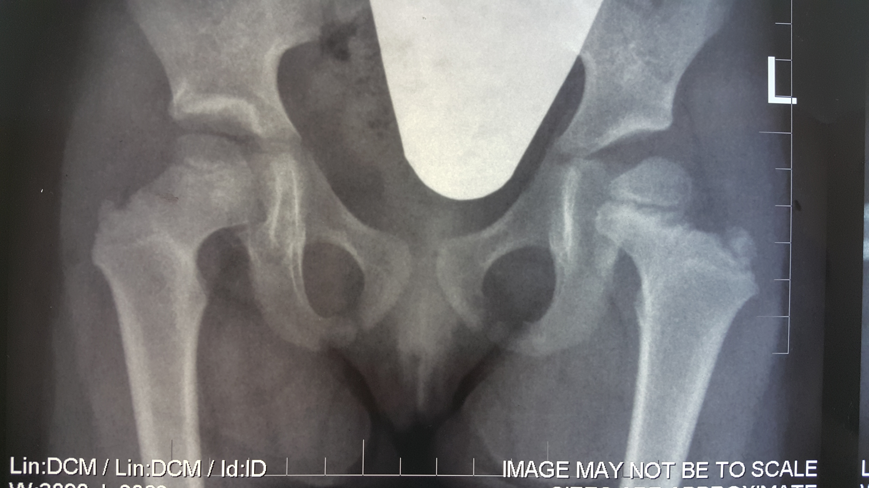
a b
Pic. 2 Destruction in metaepiphysis humerus (a) and femur(b), as a result of osteomyelitis.
Chronic recurrent multifocal osteomyelitis is a poorly understood inflammatory illness characterized by recurrent bone pain and fever. Girls are predominantly affected and have radiologic evidence of multiple, often symmetric bone lesions involving primarily the long bones and clavicles. Associated findings include psoriasis vulgaris and palmoplantar pustulosis.
BCG- osteitis nowadays is one of the key diseases that must be differentially diagnosed with acute osteomyelitis. The most frequently affected are the vertebral column, hip joint and knee joint. In elder children the development of tuberculosis process in bones is subacute, in younger children it may have acute onset, with febrile temperature. Anamnesis of such children usually contains contact with patients with open form of tuberculosis. Limb atrophy, positive Aleksandrov’s symptom (thickened skin fold), cold abscesses and lymphocytosis in blood analysis are the characteristic signs of tuberculosis of bones. Skin Mantu reaction and pus microflora (tuberculosis bacilli) with characteristic roentgenological picture: osteoporosis, little sequesters, symptom of “melting sugar”, absent periostal reaction and central localization of the focus help to make differential diagnosis.
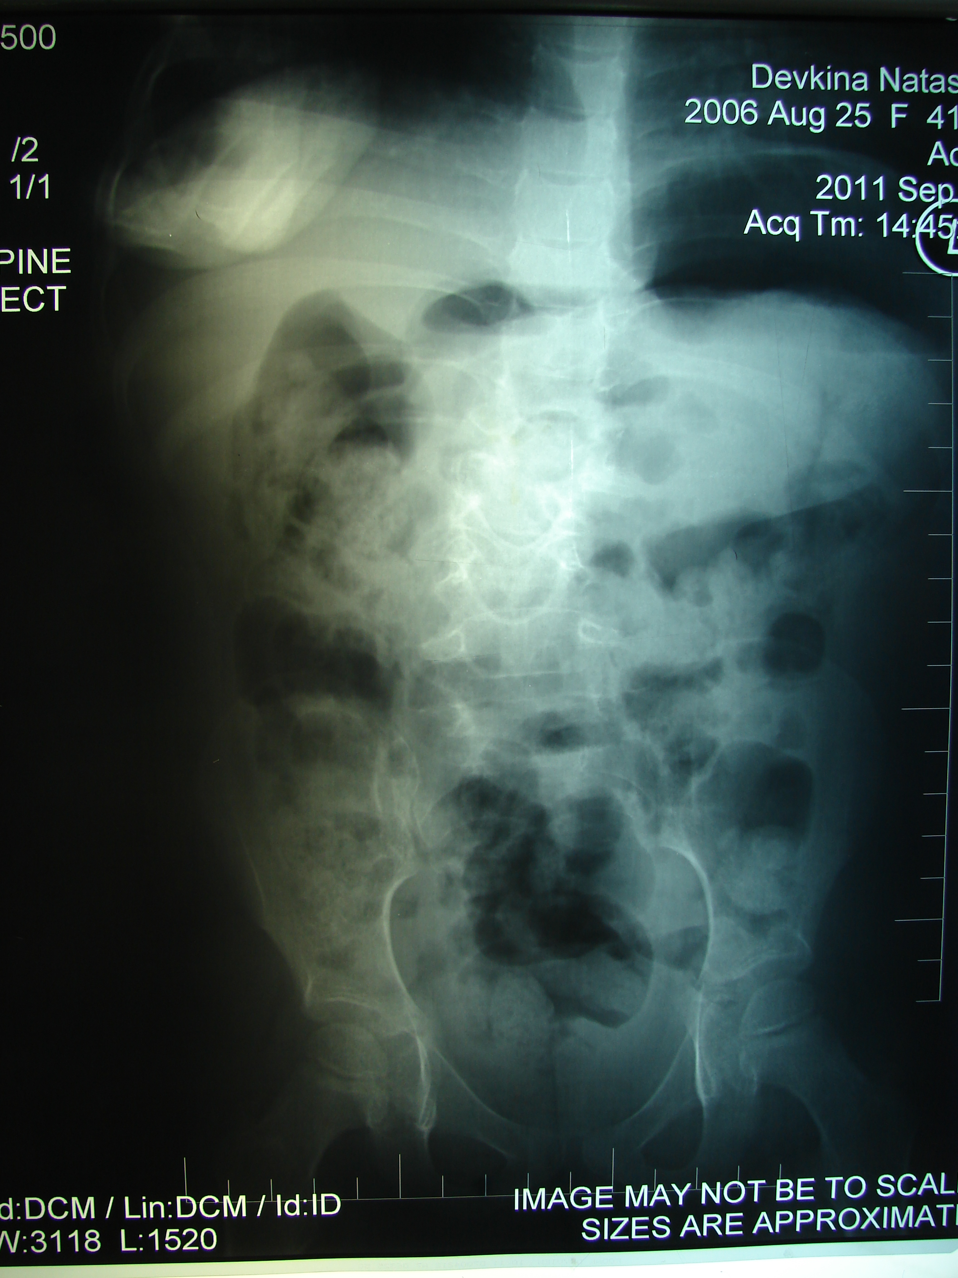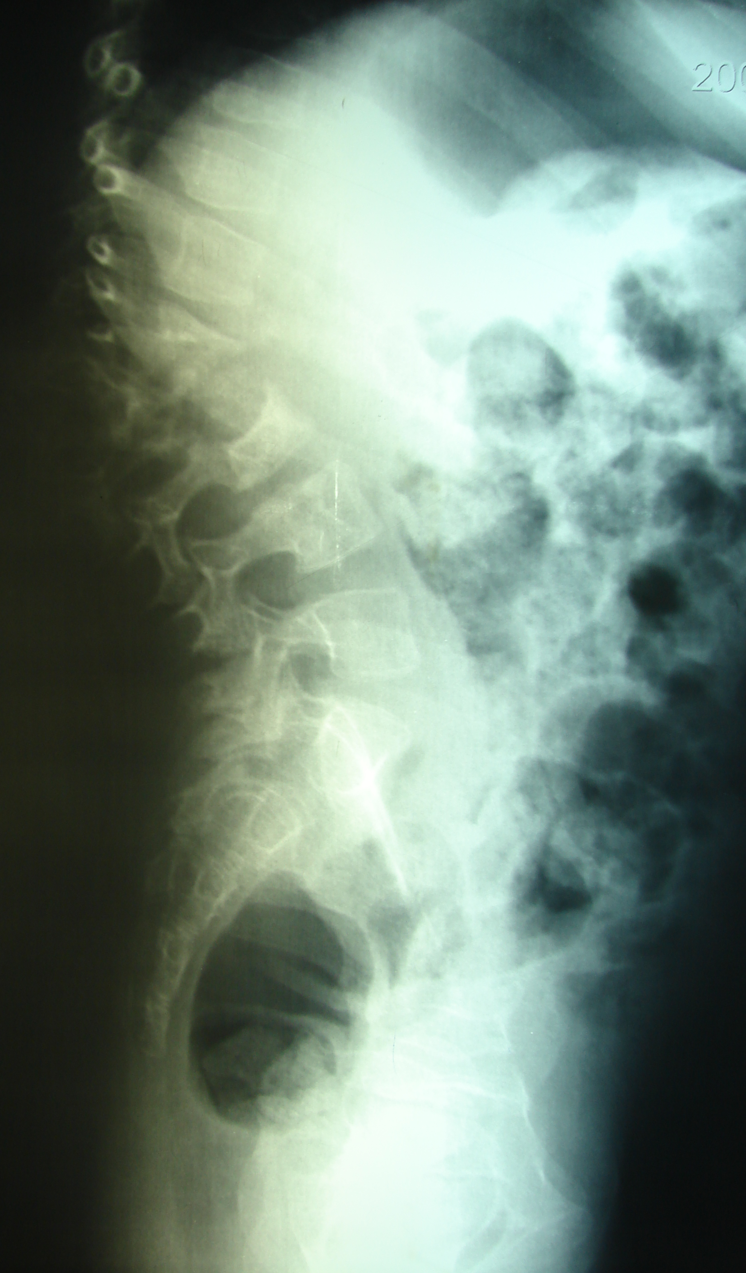
a b
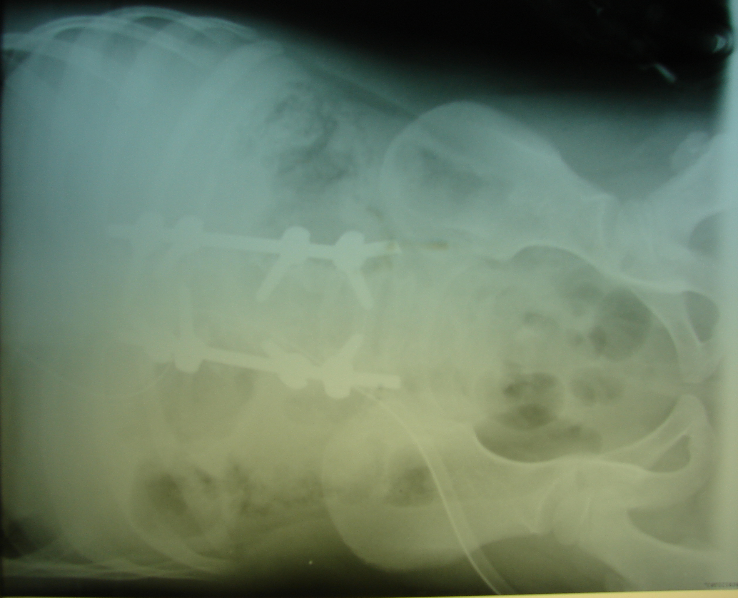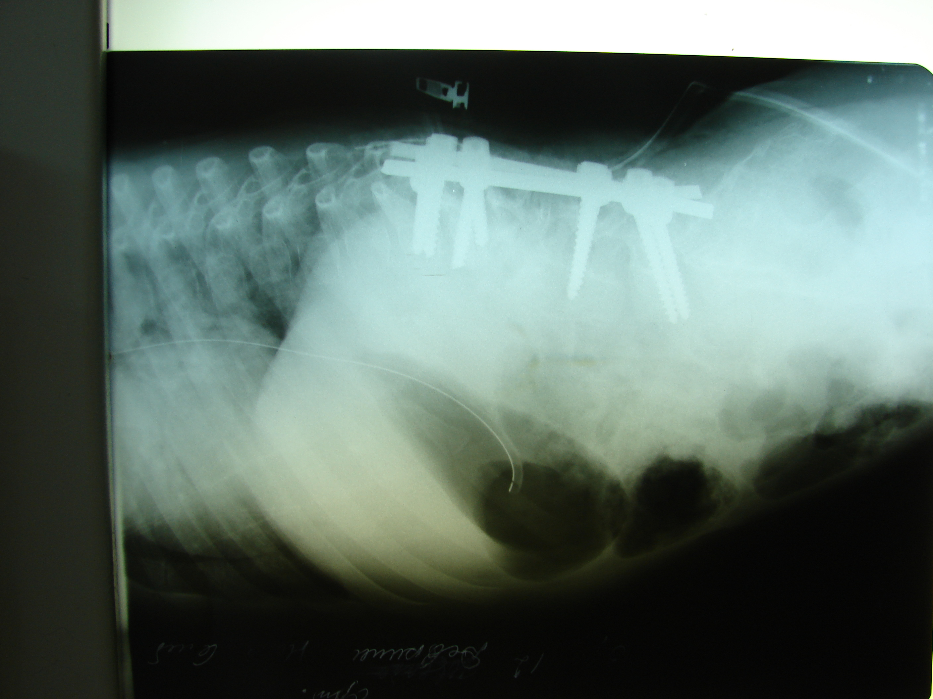
c d
Pic.3 BCG spondylitis in the lumbar spine before (a,b) and after (c,d)surgery.
Diagnosis
The diagnosis of osteomyelitis depends primarily on clinical findings and corroborative laboratory and radiographic results. The WBC count may be nor- mal or increased. Erythrocyte sedimentation rate (ESR) is elevated in 80% to 90% of cases, and C-reactive protein (CRP) is elevated in 98% of cases. ESR generally peaks 3 to 5 days after admission, and CRP peaks within 48 hours of admission. CRP typically returns to normal 7 to 10 days after appropriate therapy. ESR may remain elevated for 3 or 4 weeks, even with appropriate therapy. Patients who require surgical incision and drainage procedures may have prolonged time to normalization of ESR or CRP.
Every attempt should be made to establish a microbiologic diagnosis. A bacteriologic diagnosis can be made in 50% to 80% of cases if blood and bone cultures are obtained. In the case of culture-negative osteomyelitis that is not responding as expected to empirical therapy, a bone biopsy specimen should be obtained for histopathologic staining and for culture for bacteria, mycobacteria, and fungi. Inoculation of bone or abscess material directly into an aerobic blood culture bottle facilitates isolation of K. kingae. Cultures for K. kingae and other fastidious organisms may need to be incubated longer than usual laboratory protocol.
Plain films show soft tissue swelling in the first few days of illness. Periosteal and lytic changes in the bone generally are not seen until substantial bone destruction has occurred, usually 10 to 21 days after onset of symptoms. In some cases of proven bacterial osteomyelitis, bone changes are never seen on plain film, presumably because prompt diagnosis and treatment prevented extensive bone destruction.
The sensitivity of skeletal scintigraphy, using technetium-labeled methylene diphosphonate isotope, is 80% to 100%. Radionuclide bone scans usually are positive within 48 to 72 hours of onset of symptoms. In some cases of osteomyelitis, vascular supply to the bone is compromised, with decreased uptake of technetium to the affected area, resulting in a ‘‘cold scan.’’ Some experts prefer bone scan as the initial study in the evaluation of suspected uncomplicated osteomyelitis of the long bones. It is less expensive than MR imaging, sedation of the child is generally not necessary, and it is particularly useful when multifocal osteomyelitis is suspected or the exact location of infection is not obvious on physical examination. Radionuclide scans may be positive in other ill- nesses that result in increased osteoblastic activity, including malignancy, trauma, cellulitis, postsurgery, and arthritis.
MR imaging gives excellent resolution of bone and soft tissue. It is particularly useful for visualizing soft tissue abscess associated with osteomyelitis, bone marrow edema, and bone destruction. Contrast enhancement with gadolinium is used to look for areas of abscess formation. If pelvic or vertebral body osteomyelitis is suspected, MR imaging is the imaging study of choice. MR imaging gives better spatial resolution than bone scan and is preferred if a surgical procedure to diagnose or drain an abscess is necessary. Limitations of MR imaging include the need for sedation in younger children, high cost, and inability to assess easily whether other bones are affected.
Differentiating bone infarction versus infection can be difficult in a child with sickle cell disease. In both situations, children present with fever and bone pain and have elevated inflammatory markers. Biopsy and culture of affected bone is often necessary to establish the diagnosis. Some authors have used the pattern of MR imaging contrast enhancement to distinguish acute medullary bone infarction from osteomyelitis.
Treatment. Successful treatment of osteomyelitis depends on the appropriate selection and administration of antibiotic therapy and surgical intervention as needed. Empirical selection of antibiotics depends on the age of the child and the clinical situation. Infants 0 to 2 months old with osteomyelitis should be treated with antibiotics that have excellent coverage against S. aureus, S. agalactaiae, and enteric gram-negative bacteria.
Children 2 months to 5 years old should be treated empirically with antibiotics active against S. aureus, S. pneumoniae, S. pyogenes, K. kingae, and Hib (if not completely immunized with Hib vaccine). The American Academy of Pediatrics Committee on Infectious Diseases defines complete immunization for Hib as having had at least one dose of conjugate Hib vaccine at 15 months of age or older, two doses between 12 and 14 months of age, or a complete primary series when younger than 12 months with a booster dose at 12 months of age or older. K. kingae generally is susceptible to most b-lactam antibiotics, including second-generation and third-generation cephalosporins. It often is resistant to clindamycin, and resistance to clotrimazole is reported.
When culture results are available, antibiotic therapy is modified depending on the organism and the susceptibility pattern. If no organism is isolated, but the patient is improving, initial empirical coverage is continued. If the patient is not improving, further diagnostic testing should be considered, including bone biopsy for histopathology and culture if not previously obtained or imaging studies to rule out areas of infection that may require surgical drainage or de´bridement.
Infection caused by MRSA is increasingly common in many communities. Many isolates of CA-MRSA are susceptible to clindamycin. Isolates of S. aureus that are erythromycin resistant and clindamycin susceptible should be evaluated for the presence of inducible macrolide-lincosamide-streptogramin B (MLSB) resistance. This evaluation is done by means of a ‘‘D’’ test, performed by many hospital laboratories. Although some children treated with clindamycin for an infection with MRSA of the MLSB phenotype clear their infection, it is recommended that in the setting of serious infection, clindamycin should not be used if this phenotype is identified.
Alternative drugs to consider for treatment of osteomyelitis caused by MRSA include intravenous vancomycin, trimethoprim-sulfamethoxasole, and linezolid. Bone and joint infections caused by MRSA should be managed in consultation with an expert in infectious disease. Empirical use of these antibiotics before organism identification and susceptibility testing depends on severity of illness and incidence of MRSA in the community.
In an open-label, noncomparative, nonrandomized, compassionate use study, linezolid was used to treat serious infections caused by resistant gram-positive bacteria. Microbiologic cure for the cases of osteomyelitis caused by MRSA was 72%. Most patients in this study were adults. Side effects of linezolid include gastrointestinal symptoms and rash. Long-term use of linezolid has been associated with neutropenia, anemia, thrombocytopenia, and optic and peripheral neuropathies. Cases of lactic acidosis also have been reported with linezolid use. Linezolid was not effective in at least one animal study of experimental chronic
S. aureus osteomyelitis.
The decision to change from parenteral to oral therapy depends on the availability of an appropriate oral antibiotic, the child’s ability to take the medication by mouth, reliable caregivers, and the ability of the family to comply with frequent follow-up. Generally, oral therapy is begun when the child is afebrile, symptoms and signs of infection are resolving, and CRP is returning to normal. The availability of percutaneous central venous catheters has made home intravenous therapy of bone and joint infections an increasingly popular option. The prolonged presence of a central venous catheter increases the risk of infectious complications, including exit site infections and catheter-associated bacteremia. Intravenous therapy should not be unduly prolonged after the child has shown significant improvement.
Sequential intravenous to oral therapy is proven to be effective and safe, provided that close follow-up of the patient is ensured. The dose of oral antibiotic is generally two to three times the usual dose for children if a b-lactam antibiotic, such as dicloxacillin or cephalexin, is used. The usual recommended oral doses of clindamycin, trimethoprim-sulfamethoxazole, fluoroquinolone antibiotics, and linezolid can be used because of the excellent bioavailability of these drugs. Vancomycin always must be given intravenously.
Duration of therapy depends on extent of infection, clinical response, and presence of underlying risk factors. In general, 3 to 6 weeks of antibiotic therapy is given depending on the clinical response. There is good evidence that treatment for less than 3 weeks results in an unacceptably high rate of relapse. Chronic infection is reported in 19% of children treated for less than 3 weeks compared with 2% in children treated longer than 3 weeks.
Prognosis. Most children who receive appropriate therapy for osteomyelitis have no long-term sequelae. Recurrence of infection occurs in approximately 5% of cases. Risk factors for development of complications include delay in diagnosis, short duration of therapy, and young age at the time of initial illness. The reported incidence of sequelae in neonates with osteomyelitis ranges from 6% to 50%. Permanent abnormalities include disturbance in bone growth, limb-length discrepancies, arthritis, abnormal gait, and pathologic fractures.
There does not seem to be a significant difference in outcome for bone infections caused by MRSA compared with infections caused by methicillin- susceptible S. aureus. Children infected with MRSA tend to have longer duration of fever and prolonged hospitalization, however. Patients with complicated clinical courses, including patients with associated deep vein thrombosis, were found in one study more likely to be infected with MRSA with genes encoding for the Panton-Valentine leukocidin (PVL1). This strain of MRSA causes severe inflammatory lesions after intradermal injection in laboratory animals and has been associated with a poor prognosis in patients with pneumonia.
Chronic osteomyelitis develops in less than 5% of children after acute hematogeneous infection. It is observed more frequently after contiguous osteomyelitis. Bone necrosis occurs as a result of chronic inflammation and vascular compromise. Extensive fibrosis eventually results. Signs and symptoms of chronic osteomyelitis vary from chronic vague symptoms of swelling, pain, or intermittent drainage of the affected bone to acute exacerbations of fever, swelling, or redness over the bone. Effective management of chronic osteomyelitis usually requires surgical and medical management, with prolonged courses of antibiotics.
Pyogenic arthritis
Infection of the joint space in children usually is a complication of bacteremia. Viruses, fungal organisms, and Mycobacterium tuberculosis are uncommon causes of joint space infection. Children also may develop reactive arthritis as a consequence of bacterial infection elsewhere in the body.
Pathogenesis. Pyogenic arthritis usually occurs as a result of infection of the vascular synovium by means of hematogenous dissemination of bacteria. An acute inflammatory response follows, resulting in migration of polymorphonuclear WBCs, production of proteolytic enzymes, and cytokine secretion by chondrocytes. Degradation of articular cartilage begins 8 hours after onset of infection.
In children younger than 18 months of age, pyogenic arthritis can result from extension of a metaphyseal bone infection through transphyseal blood vessels.
The growth plate, the epiphysis, and eventually the joint space may be infected. Infection of the proximal femur and humerus often involves the hip and shoulder joints because the proximal metaphysis of each of these bones is intracapsular.
Epidemiology. Most cases of pyogenic arthritis occur in children 3 years old or younger. Cases are more frequent in boys. The joints of the lower extremities (hips, knees) are most often affected.
Microbiology. S. aureus is the most common cause of pyogenic arthritis in all age groups, and infection with CA-MRSA is becoming more common. Infants younger than 2 months of age also may have infection caused by S. agalactiae, Neisseria gonorrhoeae, and gram-negative enteric bacteria. Arthritis caused by Candida also is seen in the neonatal age group. S. aureus, S. pyogenes, S. pneumoniae, and
K. kingae are predominant organisms in the 2-month to 5-year age range. Children older than 5 years are most likely to have arthritis caused by S. aureus and S. pyogenes. N. gonorrhoeae arthritis occurs in sexually active adolescents.
Before universal immunization of children with a conjugate Hib vaccine, Hib was a common cause of pyogenic arthritis in children younger than 5 years. Infection with Hib is now rare in immunized children. Arthritis caused by
K. kingae has replaced Hib as the most common gram-negative arthritis in the child 2 months to 5 years old.
S. pneumoniae is reported to cause approximately 6% to 20% of all cases of pyogenic arthritis. The impact of the recently licensed heptavalent pneumococcal vaccine on pneumococcal pyogenic arthritis is still being evaluated. The vaccine confers immunity to the seven pneumococcal serotypes most frequently associated with invasive disease in children, but is not immunogenic against all serotypes. A surveillance study involving 157,471 children over a 3-year period after the vaccine was licensed revealed a significant decrease in the number of cases of invasive pneumococcal disease caused by serotypes in the vaccine or closely related to the serotypes in the vaccine. There was no significant change in the incidence of disease caused by other serotypes. The types of invasive disease reported were primarily bacteremia and pneumonia. Because the incidence of pneumococcal arthritis after bacteremia is only about 0.6%, a significant decrease in the number of cases of pneumococcal bacteremia is likely to result in only a small reduction in cases of pyogenic arthritis. Other causes of arthritis should be suspected on the basis of exposure history. Borrelia burgdorferi causes Lyme disease in endemic areas. Arthralgia is seen in early disseminated Lyme disease. Weeks to months after the initial infection, children may develop pauciarticular arthritis of the large joints, particularly the knees. N. gonorrhoeae infection should be considered in a sexually active adolescent with joint infection. Hematogenous spread of the organism can involve skin and joints (arthritis-dermatitis syndrome). The arthritis associated with N. gonorrhoeae also may be reactive in nature. Reactive arthritis is defined as inflammation of a joint after infection at some other site.
Clinical manifestations. Trauma or upper respiratory tract infection often precedes joint symptoms. Symptoms of pyogenic arthritis include acute onset of joint pain, fever, irritability, and limp. Pain associated with pyogenic arthritis of the hip may be referred to the groin, thigh, or knee. Findings on physical examination include redness, swelling, and warmth over the affected joint. The child complains of pain with movement of the joint and restricted range of motion. Patients should be evaluated for signs of pharyngitis, rash, heart murmur, hepatosplenomegaly, and evidence of other joint or bone involvement.
Differential diagnosis. The most common cause of hip pain in childhood is transient synovitis. Transient synovitis predominates in children 5 to 10 years old. The child generally has low-grade fever or is afebrile. Pain is usually unilateral, but may be bilateral in some cases. Pain ranges from mild to severe enough to wake the child up at night. Physical examination generally reveals a non–ill-appearing child with decreased range of motion of the hip joint.
Other causes of joint pain and swelling include reactive arthritis, juvenile rheumatoid arthritis, trauma, and malignancy. Legg-Calve´-Perthes disease is an idiopathic avascular necrosis of the capital femoral epiphysis and may cause mild pain and limp in boys (mean age 7 years). Slipped capital femoral epiphysis is the most common hip disorder of adolescents; symptoms may include abnormal gait, pain, and abnormal range of motion of the hip joint. if a child with hip pain had all four diagnostic variables of fever, refusal to walk, elevated ESR (40 mm/h) and elevated WBC count (N12,000/mm3), the probability of pyogenic arthritis was greater than 99%.
Kocher’s criteria have been applied retrospectively to patients with a known diagnosis of pyogenic arthritis. In one study, the predictive probability of presence of fever, refusal to walk, and elevated ESR and WBC count was found to be considerably less reliable (60%) in predicting pyogenic arthritis. Of patients within the group defined as having proven or presumed septic arthritis who had positive cultures, however, 35% were diagnosed with infection with coagulase- negative staphylococci. This organism is not a usual cause of pediatric pyogenic arthritis and is more often considered a contaminant. This study underscores, however, the fact that the validity of clinical prediction algorithms may vary among studies.
Other investigators have used similar methods in an attempt to differentiate pyogenic arthritis and transient synovitis. Jung et al evaluated children with hip pain using fever (N378C), ESR (N20 mm/h), CRP (N1 mg/dL), WBC count (N 11,000/mm3), and plain radiographs to determine if there was widening of the joint space (N2 mm) to predict the presence of pyogenic arthritis. If four or five of these criteria were present, the child had a high likelihood (predictive probability N99.1%) of septic arthritis and was a candidate for joint aspiration.
Although most clinicians use fever and elevated inflammatory markers to guide their management of children with hip pain, there is considerable overlap in the clinical and laboratory findings in children with pyogenic arthritis and transient synovitis. Close follow-up of patients in whom the diagnosis is unclear is crucial. Plain radiographs are obtained to rule out fracture, malignancy, or osteomyelitis as the cause of pain. Ultrasound is useful in determining whether fluid is present in the hip joint and is used to guide joint aspiration. Ultrasound cannot differentiate infected from noninfected fluid.
Management. The successful management of pyogenic arthritis depends on timely decom- pression of the joint space and institution of appropriate antibiotic therapy. Children with pyogenic arthritis should be managed in collaboration with an orthopedic surgeon experienced in the treatment of pediatric bone and joint infections. Aspiration of the affected joint usually is performed for diagnostic and therapeutic purposes. In the case of hip and shoulder joint infections, prompt surgical drainage of infected joint fluid usually is required. The initial choice of empirical antibiotic therapy depends on the age of the child, clinical presentation, and local patterns of antibiotic resistance. In general, infants younger than 2 months old are treated with nafcillin and a third-generation cephalosporin to cover S. aureus and enteric gram-negative bacteria. Older children should receive antibiotic therapy active against S. aureus, S. pyogenes, and K. kingae. If N. gonorrhoeae is suspected, ceftriaxone should be used. Clindamycin is an appropriate antibiotic for most gram-positive bacteria, in cluding some strains of CA-MRSA. It is not active, however, against K. kingae. If MRSA is suspected, vancomycin should be used empirically until culture and susceptibility results are available. If cultures are positive for MRSA, clindamycin is an appropriate drug if the isolate is susceptible, and there is no evidence of the MLSB phenotype (see the section on osteomyelitis). Intra-articular injection of antibiotics is not appropriate. Most antibiotics achieve high synovial fluid concentrations, and the antibiotic may cause a chemical synovitis when directly injected into the joint. As with osteomyelitis, a child should be treated with intravenous antibiotics until there is significant clinical improvement, inflammatory markers are returning to normal, and the child’s oral intake is normal. The doses of oral antibiotics used are the same as doses used to treat osteomyelitis.
Some centers have found the use of guidelines helpful in standardizing care of uncomplicated cases of pyogenic arthritis. Use of short courses of intravenous therapy (3–4 days) followed by the appropriate oral antibiotic decreased the duration of hospitalization at one center. Compared with patients who were treated before implementation of guidelines, there was no increase in the risk of adverse outcomes in patients followed a minimum of 1 year. Although clinical guidelines may be useful as a framework for evaluation and treatment of pyogenic arthritis, strict guidelines are not appropriate for children with underlying risk factors for severe disease or for children not responding to initial therapy.
The duration of therapy for uncomplicated pyogenic arthritis depends on the response to therapy and the suspected organism. Generally, infections with
S. pneumoniae, K. kingae, Hib, and N. gonorrhoeae are treated for 2 to 3 weeks. Infections caused by S. aureus or gram-negative enteric bacteria are treated 3 to 4 weeks.
Prognosis. Complications of pyogenic arthritis include abnormal bone growth, limp, un- stable articulation of the affected joint, and decreased range of motion. Complications are reported in approximately 10% to 25% of all cases. Risk factors for sequelae include delay in time to diagnosis of more than 4 or 5 days, onset of disease in infancy, infection with S. aureus or gram-negative bacteria, and infection of adjacent bone. In one study from Costa Rica, a 4-day course of dexamethasone given with appropriate antimicrobial and surgical therapy de- creased the duration of symptoms and long-term joint dysfunction. Further studies are needed to confirm the benefits and risks of this treatment approach.

Metaepiphyseal osteomyelitis of newborns (septic arthritis)
The course of the disease is usually independent, but can be a manifestation of sepsis.
Etiology and pathogenesis. The causes of septic lesions of joints in newborns are the chronic urogenital mother infection that is transmitted to the fetus in utero, the introduction of drugs through the umbilical and central veins, the resuscitation in maternity hospitals, vaccination, purulent soft tissue and mucous membranes affections. In most cases the process is localized in the femur, humerus, tibia epiphysis. Some authors (YP Kukuruza, OJ Antipin, VS Konoplitsky et al., 1998) believe that the focus of inflammation first appears in the bone metaphysis, and only then the inflammatory process extends to the epiphysis and the articular surface, the septic infarctions with massive perifocal inflammation develop, that cause the irreversible destruction germ zones (VI Stetsula, VV Grigorovskiy, 1980; VI Stetsula, 1989).
The clinical presentation. By the clinical course two forms are distinguished: localized (local focal) and toxicoseptic forms.
Localized form is characterized by the gradual onset. First, there is flaccidity, body temperature rises to subfebrile digits. Gradually general condition is deteriorating, signs of intoxication are not very evident. When you change the position of the body the baby starts crying, becomes restless. Local symptoms are very evident at the end of 2-3 days (sometimes later) after the onset of disease.
Toxicoseptic form of metaepiphyseal osteomyelitis is characterized by acute onset with a rapid rising of body temperature to 38.5 ~ 39 ° C. The general condition is deteriorating: the child refuses to eat, his features sharpened, the skin becomes grey. Weakness develops, reaction to people around is reduced. Very often dyspepsia occurs (vomiting, diarrhea). There may be convulsions.
Leading symptom of metaepiphyseal osteomyelitis is pain, first nonlocalized, later - limited by the lesion focus. During the examination a forced position of the affected limb is detected. So, with the affection of the proximal epiphysis of the humerus the arm is adduced to the body, movements in the joints are absent. The distal epiphysis of the humerus is affected very rarely. In the case of involvement in the pathological process of the distal and proximal epiphysis of the radius and ulna one always finds flexion contracture of the elbow.
Complications. Metaepiphyseal osteomyelitis is complicated by multiple purulent foci, which significantly worsen the prognosis of the disease, and by pathological dislocations. The latter arise as a result of the affection of the proximal epiphysis of the femur. There are distensional and destructive - pathological dislocations. The first - the head of the femur gets out of the acetabulum by the action of the sciatic muscle, the second - the head and the femoral neck are destroyed. The late complications include violations of limbs as a result of the defeat of its germ zones, so children with metaepiphyseal osteomyelitis have to be subject to mandatory medical check-ups in order to timely detect complications that cause considerable deformations of limbs and so-called growing pains (PT Syagaylo, 1986).
Diagnosis of septic arthritis is based on clinical, cytology, ultrasound and X-ray methods of study. The cytology of joint fluid plays an important role in the early diagnosis. Identification of more than 10 white blood cells per 1 ml of fluid, lack of function and change of the configuration of the joint give reason to suspect the presence of septic.
Results of laboratory research at metaepiphyseal osteomyelitis in the first days of disease are non-specific: leukocytosis, neutrophilia with a shift of leukocyte formula to the left. ESR is usually increased. Increasing signs of anemia, the lack of eosinophils and monocytes are unfavorable indicators.
Ultrasound confirms the presence of arthritis according to increased joint space, changed joint configuration and excessive amount of fluid in the joint capsule. This method is used for the early detection of pathological changes in the epiphysis affected by inflammation.
In view of the lack of bone tissue in the most epiphysis, the degree of their damage often can be determined in older children with the help of X-ray examination.
The X-ray examination in the 10-14-th day of illness is the most rational. To refuse the application of this method is inappropriate. It allows you to put a definitive diagnosis, to identify and estimate the dynamics of complications of the disease. X-ray of the affected limbs has to be performed for the comparative monitoring of bone, as well as to avoid possible fracture. The first indirect radiological signs of metaepiphyseal osteomyelitis are expansion of joint space and minor destructive changes of epiphyseal cartilage. They are more noticeable when comparing healthy and diseased limbs.
At 7-10 th day of the metaepiphyseal osteomyelitis periosteal layers appear. Sequestration is not observed.
The causative agent of sepsis is detected by bacteriological and serological studies. With the help of immunological monitoring the primary congenital immunodeficiency is revealed, requiring substitutive therapy. Biochemical studies indicate an increasing the levels of alkaline phosphatase and transaminases.
Differential diagnosis should be done with traumatic brachial plexus (Erb-Duchenne paralysis), fractures. If focus of inflammation is localized in the proximal epiphysis of the femur, the lower limb is bent at the hip joint, rotated out and abducted. Active movements of the hip and knee joints are absent, passive - are sharply painful, especially rotational. The affection of the bones epiphyses forming the knee joint is accompanied by a flexion contracture at an obtuse or right angle. Metaepiphyseal osteomyelitis in the ankle area causes ​​the foot flexing, fingers immobilization.
Under the inflammation of the epiphysis of bones forming joint, the arthritis phenomena are developing, their palpation is very painful, the child is restless. Local signs of metaepiphyseal osteomyelitis, which appear after 2-3 days after the onset of the disease, include diffuse swelling, joint smoothed contours caused by arthritis and swelling of the surrounding soft tissues. Palpation shows an increase in local temperature, painfulness, dense infiltrate around the bone epiphysis. The skin color some time remains unchanged. In case of damage of the elbow, wrist, ankle joints the described symptoms are observed earlier and much later - in the affection of the hip and shoulder. In the neglected or late diagnosed cases in the place of an abscess breakthrough phlegmons are formed. The flushing of the skin appears, the local temperature rises, a network of expanded veins is formed over the joint, the skin becomes cyanotic.
Treatment should be individualized, nevertheless we need to follow to the principles proposed by TP Krasnobaev (1951): Effects to: a) the macroorganism; b) the microorganism; c) the focus of inflammation; mandatory immobilization of the affected limb. The impact on the macro-organism in severe metaepiphyseal osteomyelitis begins immediately after hospitalization. First of all, a system for intravenous introduction of drugs is established (10% glucose solution, Ringer solution with vitamins calculated daily physiological demand, fresh frozen native plazma - 10-15 ml per 1 kg body’s weight). In the acute phase the passive immunization is performed: usage of hyperimmune compositions with a high antibody titer. Immunotherapy is preferably carried out after the determination of the main indicators of the immune system and pathogens. If the association of microorganisms is identified, more than one kind of hyperimmune plasma, but two or more (with antistaphylococcal, antiproteus or pseudomonas) is prescribed. The same applies to the prescribing of gamma-globulin.
Along with the infusion therapy extracorporeal detoxification methods are used: plasmapheresis, UV and laser irradiation of blood and bone marrow channel, HBO, enterosorption.
To restore microcirculation Anticytokine therapy is prescribed - aprotinin (contrycal), pentoxifylline, physiotherapy: magnetic laser therapy, HBO, ultrasonic cavitation of medullary canal (SV Shestobuz, BM Bodnar, 2007), according to indications - antifungal therapy and probiotics.
Effect on the microorganism is carried out with antibiotics, selection of which is priority. A large number of antimicrobial agents greatly complicates the choice of antibiotic for effective treatment. At the present stage the pathogens of metaepiphyseal osteomyelitis are gram-positive and gram-negative flora and anaerobic infection. With this in mind, you need to prescribe those antimicrobials that affect all pathogens: carbapenem (imipenem, meropenem), cephalosporins II generation (tsefmetazon, tsefotetan), III generation - tsefanerazon, ceftriaxone, tseftazitsim, IV of generation - tseftrizoksin (geksetil, tsefrozil). According to some authors (VP ​​Sleptcov, DV Shaevsky, AY, Vershinin, 1998), these antibiotics are considered to be universal and should be applied at the beginning of treatment.
The impact on focus of inflammation. If signs of the formation of effusion in the joint have appeared you have to carry out its puncture. The resulting liquid is sent to a laboratory for testing for the presence of microflora and sensitivity to antibiotics. In the presence of pus the joint has to be washed by antiseptic, antibiotics, other antiseptic. A puncture is performed every day or every other day (depending on the amount of pus in the joint). In severe cases, when conservative treatment is ineffective, and the child's condition does not improve, it is possible to enter into the joint 1-2 thin plastic catheters for continuous washing and removal of pus. It is very rare in neonates with metaepiphyseal osteomyelitis arthrotomy is performed. It should be avoided, especially if the large joints are affected (shoulder, hip, knee).
The immobilization of the affected limb must be performed to all children. The particularities of applying the retention bandage are determined by the localization of the pathological focus.
The distensional and destructive and pathological dislocations are treated with the help of adhesive plaster traction, followed by immobilization on diverting splints for a long time (at least 3 months.). X-ray control (or ultrasound sonography) is performed 1 time per month to monitor the recovery both the neck and the femoral head.
MRI is used to determine the degradation of the proximal femur, to reveal the cartilage head or its remains, to find out the feasibility of the continuation of conservative therapy: closed reduction using the functional method, the fixation with the help of Gnevkovskyi device or performing reconstructive surgery. With the help of MRI one can establish the presence of the ossification nucleus and determine the timing of surgery.
The extent of operation depends on the severity of the pathological process: it can be a simple open reduction of dislocated head, and if necessary - with a corrective osteotomy of the femur (shortening, detorsional, varus) and acetabuloplasty for Pemberton. The complex reconstructive surgery with mobilization of the proximal femur and the relegation of the greater trochanter are performed. This is a problem that needs a final resolving. In each case the early functional work out of the affected joints is indicated. If necessary, a corrective osteotomy of the femur and metalosteosynthesis using the L-shaped plate are carried out.
Sepsis
Sepsis from an infectious etiology is a major cause of morbidity and mortality. Despite recent advances in neonatal and pediatric critical care medicine, the number of children suffering from sepsis continues to rise. A review in the New England Journal of Medicine reported an 8.7% annual increase in the incidence of sepsis. Infants were affected more often than older children.
Sepsis can be caused by a variety of insults, including infection or tissue injury. Invasive microbial infections often result from the inability of the intrinsic host defense mechanisms to combat certain virulence factors. The most frequent organisms identified in the pediatric and adult populations include Escherichia coli, Pseudomonas aeruginosa, Klebsiella, and Bacteriodes species. The most common pathogens in the neonatal population are group B streptococci and E. coli. These pathogens induce a localized inflammatory response in the host designed to destroy the microorganisms. Lack of control, over-exuberance of this inflammatory response, or inability of the host to eradicate the infection may lead to a clinical syndrome characterized by fever, inadequate tissue perfusion, organ dysfunction, and generalized edema. This constellation of symptoms is referred to as the sepsis syndrome or the systemic inflammatory response syndrome (SIRS). This may represent the final common pathway through which microbial infection or extensive tissue injury results in the demise of the host.
Microbial invasion has different consequences in the neonate compared to the adult. The neonate’s immune system is premature and its ability to ward off infection is dampened secondary to low levels of certain inflammatory mediators. The neonate can manifest the symptoms of the sepsis syndrome in a number of ways. The following criteria help to define these characteristics in the pediatric population. The criteria consist of:

- Clinical evidence of sepsis with fever (rectal temperature > 38°C) or hypothermia (<35.6°C)
- Tachycardia (heart rate > 95th percentile for age)
- Tachypnea (respiratory rate > 95th percentile for age)
- Hypotension (mean arterial blood pressure < 5th percentile for age)
- Altered mental status, metabolic acidosis (arterial pH < 7.35 or base deficit > −5),
- oliguria (urine output< 1 ml /kg/h) or signs of poor peripheral perfusion, such as delayed capillary refill.

In addition, the diagnosis of SIRS includes most of the Bone criteria, but includes a white blood cell count greater than 12,000 cells/mm3 or less than 4,000 cells/ mm3 or the presence of 10% bands. The use of white blood cell count in the neonate is of limited value since less than 50% of neonates with values greater than 20,000/mm3 or less than 4,000/mm3 are ultimately diagnosed with a bacterial infection. The ratio of immature to total neutrophils is useful in determining the likelihood of infection in the neonate. A ratio greater than 0.2 is a sensitive indicator of infection, while a ratio greater than 0.8 or severe neutropenia sig- nifies severe bone marrow depletion and a poor prognosis. Thrombocytopenia is a nonspecific and late predictor of neonatal sepsis, but trends in platelet count are important for the clinician to address.
The most prominent clinical or physiologic changes that occur in SIRS are reduced vascular resistance and decreased peripheral extraction of oxygen. The pediatric patient must increase cardiac output and increase minute ventilation to achieve a higher delivery of oxygen to ischemic tissues. The inability to increase oxygen delivery causes marked anaerobic metabolism with the production of excess lactate.
The 2001 International Sepsis Definitions Conference proposed a purely biochemical or immunological, rather than clinical, criteria to identify the inflammatory response in children. C-reactive protein (CRP), interleukin 6 (IL-6), and procalcitonin (PCT) were mentioned as potential markers for use in the neonates and pediatric patients. PCT is secreted during gram-negative sep- sis from an unknown extrathyroid source and can be used as a guide for antibiotic therapy. Maja Pavcnik-Arnol et al. performed a prospective observational study looking at potential biochemical markers that could diagnose bacterial sepsis in the neonate. In critically ill neonates less than 48 h old, LBP on the first day of suspected infection was a better marker of sepsis than IL-6 and PCT and was similar to CRP. In critically ill neonates older than 48 h and in children, LBP was a better marker than IL-6 and CRP and was similar to PCT. In culture confirmed sepsis, LBP had 91% sensitivity, 98% negative predictive value, 85% specificity, and 52% positive predictive value.
The objective in diagnosing the cause of sepsis in the neonate is to isolate bacterial or fungal organisms and then treat with appropriate antibiotics. Documentation of bacterial infection in suspected neonates is positive in only 10% of cases. Cultures should be obtained from peripheral blood as well as any indwelling intravenous lines. The presence of microorganisms in the blood is the initiating event, leading to fever and chills 1–2 h after the development of bacteremia. Blood cultures are frequently negative at the time of the temperature spike. Thus, blood cultures are ideally drawn prior to the onset of a temperature spike. In reality, however, this is not possible; therefore, spreading out the collection of blood cultures increases the likelihood of blood collection during bacteremia. It is therefore recommended that separate needle sticks be obtained from different venipuncture sites. Once bloodstream infection is identified, repeat or follow-up cultures are not necessary in most cases. Subsequent blood cultures may be justified, however, in patients who deteriorate clinically, or who fail to improve despite appropriate antibiotic therapy. In some cases bacteremia may be prolonged, necessitating further blood cultures during treatment. Urine cultures as well as lumbar puncture should be performed since up to one-third of neonates can have meningitis. Unfortunately, no single laboratory test can diagnose sepsis or SIRS in the neonate; however, the use of the physical exam and history may give insight into the cause of a patient’s decline.

Management
As stated in the previous section, the most prominent feature of sepsis or SIRS is the increase in oxygen demand by end organs and a decrease in vascular resistance, which is manifested as a low blood pressure. In the treatment of sepsis or the early stages of SIRS, the goal is to increase oxygen delivery by aggressive fluid resuscitation, cardiovascular and respiratory support, and optimal management of fluids and electrolytes, hematologic, renal, metabolic, and nutritional needs. Initial fluid boluses of 20 ml/kg of normal saline are required to correct hypovolemia. Rapid fluid resuscitation in excess of 40 ml/kg in the first hour following emergency department presentation was associated with improved survival, decreased occurrence of persistent hypovolemia, and no increase in the risk of cardiogenic pulmonary edema in a group of pediatric patients with septic shock. The use of vasopressors is withheld until the child is adequately resuscitated. If vasopressors are to be used, then dopamine is chosen first because it stimulates dopaminergic receptors and potentially increases renal blood flow. The physician should monitor the urine output as a guide to end organ perfusion and adjust the management accordingly (1–2 ml/kg/h). In addition, since respiratory failure is often seen in a septic neonate, mechanical ventilation may be important to help relieve the failing respiratory muscles. Adjustment to the respiratory rate or to the oxygen con- centration on the ventilator is governed by arterial blood gas.
Source control with antimicrobial therapy is the cornerstone of treatment of presumed sepsis or infectious causes of SIRS. Broad-spectrum antibiotics should be started at the first signs of sepsis. Most patients with sepsis or infectious SIRS are diagnosed with Gram-negative infections such as E. coli,
P. aeruginosa, Klebsiella, and Bacteroides species. In neonates or term infants, the most common organisms encountered are group B streptococcus, E. coli, and L. monocytogenes. The antibiotics should be tailored to the species and sensitivities identified in the blood, urine, or lumbar puncture. If fever persists despite empiric antibiotics and no source of infection has been identified, empiric antifungal therapy may be indicated if the patient has risk factors for candidal infection.
In severe sepsis or SIRS, activation of the inflammatory cytokine and coagulation cascades may lead to thrombin production and fibrin deposition in the microvasculature or microvascular thrombosis. During systemic Gram-negative and Gram-positive bacterial infections, activation of coagulation is mediated via the extrinsic tissue factor pathway. Activated protein C is an endogenous regulator of coagulation and inflammation and is a promising therapeutic target in patients with severe sepsis. The PROWESS (Protein C Worldwide Evaluation in Severe Sepsis) study was a large multicenter randomized double blind, placebo- controlled trial in patients with severe sepsis. The trial demonstrated a decrease in the 28-day mortality from all causes in adults with sepsis. An interim analysis of pediatric patients found an increase in the levels of protein C and antithrombin in addition to a 5% incidence of serious bleeding. More studies are needed to see if Activated protein C is a viable option in the pediatric population.
Sepsis or SIRS causes a release of inflammatory cytokines and hormones that lead to hyperglycemia. Increased peripheral insulin resistance is caused by a release of cortisol, TNF and IL-1. In addition, there is an increase in hepatic glucose production, which causes hyperglycemia. Elevated blood glucose causes an increase in microbial infections and increased mortality. A landmark study by van den Berghe and colleagues demonstrated that tight glycemic control with a blood glucose level of 80–110mg/dl decreases in-hospital mortality by 34% in a mixed medical-surgical ICU (predomi- nantly cardiac surgery patients) compared to patients with a targeted blood glucose level of 180–200 mg/dl. In septic neonates, hyperglycemia correlated with pro- longed ventilator dependency and increased hospital length of stay. Adhering to strict glucose control can help neonates and infants decrease the mortality associ- ated with sepsis or SIRS.
Nutritional support of the infant with enteral or parenteral feeding during sepsis is important to help provide necessary nutrients. The advantages of enteral as compared with parenteral feeding include gastric pH buffering, avoidance of the use of parenteral-nutrition catheters, preservation of gut mucosa with the avoidance of the introduction of bacteria and toxins from the gastrointestinal tract into the circulation, and a more physiologic pattern of enteric hormone secretion.

General references:
- Neff L.L., Rahbar R. Pediatric head and neck / In: Greenfields Surgery Scientific Principles&Practice, 6th edition, 2017 – P. 132-147.
- Pediatric surgery – 7th edition / editor in chief A.G Coran ; associate editors, N.S. Adzick, A.A. Caldamone, T.M. Crummel et al., Philadelphia, 2013 – P. 141-169.
- Puri Prem. Pediatric Surgery. Springer 2006; 998.

Supplemental references:

- Lew DP, Waldvogel FA. Osteomyelitis. Lancet 2004;364:369–79.
- Nakagawa S, Shime N. Respiratory rate criteria for pediatric systematic inflammatory response syndrome. Pediatr Crit Care Med 2014; 15:182.
- Hartman ME, Linde-Zwirble WT, Angus DC, Watson RS. Trends in the epidemiology of pediatric severe sepsis. Pediatr Crit Care Med 2013; 14:686.
- Montague EC, Hilinski J, Andresen D, Cooley A. Evaluation and treatment of mastitis in infants. Pediatr Infect Dis J 2013; 32:1295.
- Dartnell J, Ramachandran M, Katchburian M. Haematogenous acute and subacute paediatric osteomyelitis: a systematic review of the literature. J Bone Joint Surg Br 2012; 94:584.

Incoming control tests:

1. For the hematoxin released under anaerobic gas infection, the following properties are not characteristic:
A) necrosis of connective tissue and muscles;
B) hemolysis;
C) thrombosis of blood vessels;
D) lesions of the myocardium, liver, kidneys;
Е) selective brain damage.
Standards of answers:
Correct answer Е. Hematoxin leads to hemolysis (response B), necrosis of connective and muscle tissue (response A), vascular thrombosis (response B), and damage to the tissues of the myocardium, liver and kidneys (answer D).

2. The progression of shock in a septic patient is evidenced by:
A) the patient's condition which is getting worse gradualy;
B) a sharp decrease in diuresis and a violation of microcirculation;
C) the presence of metabolic disorders;
D) prolonged hyperthermia;
E) presence of metastatic foci of infection.
Standards of answers:
Correct answer B - centralization of blood circulation, as evidenced by a decrease in diuresis and a violation of microcirculation is specific for shock.
Gradual deterioration in the patient's condition (answer A), the presence of metabolic disorders (response B), prolonged hyperthermia (response D), and the presence of septic foci of infection (response E) correspond to the course of sepsis.

3. With a child who underwent acute hematogenous osteomyelitis the process did not exacerbate within 2 years. The indicated variant of the current is:

A) to breakaway;
B) to the protracted;
C) to lightning;
D) to chronic;
E) to septicopyemic.
Correct answer A. In the abrupt version of the course of the disease, the disease ends in complete recovery within 2 to 3 months.
With a protracted variant (variant B), a subacute long-term course of the disease is noted. Recovery nevertheless occurs after a lapse of 6 to 8 months of treatment.
With the lightning-fast version (variant C), a massive release of bacteria into the blood occurs, often staphylococci. Without the provision of massive medical assistance, death of the brain occurs in 6 minutes. Chronic (variant D) the course of the disease is long - more than 6 - 8 months with periods of remission and relapses. Characteristic formation of sequesters (areas of dead tissue), long-lasting inflammation.
Septicopyemic forms (variant E) are dominated by septic ulcerations with the formation of metastatic abscesses in other organs.

4. When measuring intraosseous pressure in case of suspicion of acute hematogenous osteomyelitis, the level is taken as the norm:

A) below 90 mm. w.c.;
B) 96-122 mm. w.c.;
C) 122-140 mm. w.c.;
D) 140-160 mm. w.c.;
E) 160-180 mm. w.c.
Correct answer option B. Normal value of intraosseous pressure 60-100 mm of w.c. in healthy children. Variant A reflects lower values, and variants С, D, Е are higher, in comparison with the norm.

5. Measurement of intraosseous pressure in patients with suspected acute hematogenous osteomyelitis is indicated when:

A) the presence of pain in the limb and high temperature;
B) in case of anamnesis in the absence of traumatic injuries;
С) in the syndrome of edema of paraarticular soft tissues;
D) in all the cases indicated.
At the clinic of hematogenous ostiomyelitis, the edema of the affected area is marked (variant B), painful contracture of the adjacent joint, elevation of the local temperature (variant A) is noted. The detection of these changes in a patient with no history of injury (option B) is the reason for conducting a diagnostic puncture of the alleged lesion. The most complete answer is a variant of D.
6. Which of the listed bones is most often affected by osteomyelitis of newborns?
A. ray
B. parietal
C. club
D. collarbone
E. femoral

Answer E. The most common localization in osteomyelitis of newborns is the femoral bone. After it, the frequency of lesions is followed by shoulder and tibia bones. Radical bone (option A), parietal (option B), club (option C) and collarbone (option D) are affected much less frequently.

7. The most frequent septic focal point for neonatal sepsis is:
A. a complicated ulcerative-necrotic enterocolitis;
B. a mastitis of newborns;
C. a purulent omphalitis.
D. a paraproctitis
E. an osteomyelitis of long tubular bones;

The correct answer is variant E. The most vulnerable to purulent organ metastases are the lungs, where metastases are always small, multiple, located along the periphery of the lungs, evaluated clinically and radiologically as secondary (septic) destructive pneumonia. The second place after the pulmonary in the frequency of purulent metastases occupy bones (variant E), the third - subcutaneous tissue and skin, and then kidneys and other organs and tissues (variants A, B, C, D).

8. In what form of omphalitis is conservative treatment possible on an outpatient basis?
A. With a simple omphalitis
B. With purulent omphalitis
C. With phlegmon navel
D. With gangrene navel
The correct answer is A. With simple omphalitis (wetting navel), treatment consists in changing the treatment regime of an unhealed umbilical wound - not 1-2 times a day, but with each swaddling. This form does not require general treatment and hospitalization.
With purulent omphalitis (Varinat B), local treatment changes: before processing the navel with the above mentioned solutions it is treated with a 2% solution of hydrogen peroxide and thoroughly dried, the treatment is carried out every swaddling. Purulent omphalitis requires the prescription and general treatment - antibiotics. The patient is hospitalized in a therapeutic hospital.
The phlegmon of the navel (variant C) and the navel gangrene (variant D) require surgical intervention and are treated in a surgical hospital.

9. Surgical intervention is indicated:
A. With simple omphalitis
B. With purulent omphalitis
C. With phlegmon navel or gangrene navel
D. All options
The correct answer is C. With the phlegmon of the navel, surgical intervention is indicated, which consists of applying incision-incisions of hyperemic and swollen skin around the navel with the dilution of wounds, washing them with antiseptic solutions and draining with narrow strips of glove rubber. Surgical intervention with gangrene of the navel is more extensive in area, for the general therapy combinations of antibiotics acting on gram-negative flora are necessarily used, and detoxification therapy is also prescribed.
With simple and purulent omphalitis (variants A and B), surgery is not indicated.

10. Which of the following statements is incorrect for infectious inflammatory diseases in newborns?
- aptitude to generalization
B. aptitude to neurotoxicosis
C. rapid swelling
D. fast tissue necrosis
E. frequent lesions of the lymph nodes

Answer E - in newborns, the barrier function of the lymph nodes is reduced, so their lesion is not frequent.
The tendency of tissues to swell (variant C), the rapid onset of tissue necrosis in case of purulent lesions (option D), the tendency to generalize the infection (option A) and neurotoxicosis (option B) are typical for newborns.

Outcoming control tеsts :

1. Which of the following is an appropriate initial therapy for both septic shock and cardiogenic shock?
(A) prophylactic antibiotics
(B) beta blockers
(C) volume resuscitation with crystalloid fluids
(D) mechanical ventilation
(E) diuretics

The usual early hemodynamic response to sepsis is a hyperdynamic circulation. This includes tachycardia, elevated cardiac output, and decreased systemic resistance. Septic shock may then progress with intractable hypotension, metabolic acidosis, reduced cardiac output, oliguria, and death. The initial resuscitation of patients with all forms of shock requires rapid expansion of circulating blood volume to help maintain BP and tissue perfusion. This is usually achieved with the infusion of crystalloid fluids. When septic shock is suspected, cultures of blood, urine, and other sources along with antibiotic therapy targeted toward the most likely source is critical. Mechanical ventilation may be required when altered mental status, acidosis, and hypoxia are present. Beta-blockers and diuretics may have specific indications that cardiac ischemia and pulmonary edema are present. (Kasper et al., 2005, pp. 1600–1606)

2. The patient is intubated, given 2.5 L of NS and empiric antibiotics, and central venous access is obtained. Repeat vital signs show persistent tachycardia with a blood pressure of 85/48 mm Hg. The patient has no urine in the Foley catheter bag. CBC reveals a white blood cell (WBC) count of 16,500 cells/mm3, a blood urea nitrogen/creatinine (BUN/Cr) of 63/2.1, and lactic acid of 3.9 units. Arterial blood gas shows a mixed respiratory alkalosis with metabolic acidosis. Chest radiography reveals a dense consolidation in the left lower lung base consistent with pneumonia.

Which of the following is the most likely additional diagnosis?

a. Systemic inflammatory response syndrome (SIRS)
b. Sepsis
c. Severe sepsis
d. Septic shock

Answer d. Septic shock
Systemic inflammatory response syndrome (SIRS) is a global inflammatory state that yields a particular set of symptoms and objective findings, and occurs prior to sepsis and shock. There are four components of the SIRS criteria:

1. Body temperature <36°C or >38°C
2. Heart rate >90 beats/min
3. Tachypnea >20 breaths/min; or PCO2 <32 mm Hg
4. WBC count <4000 cells/${mm}^{3}$ or >12,000 cells/${mm}^{3}$

Two criteria = SIRS
Two criteria + Source of infection = Sepsis
Two criteria + Source of infection + Organ dysfunction = Severe sepsis
Two criteria + Source of infection + Organ dysfunction + Hypotension = Septic shock
This patient has four criteria: tachypnea, tachycardia, an elevated WBC count, and a fever. This combined the lungs as a source, confusion (brain dysfunction), and evidence of renal dysfunction yields severe sepsis. However, because the patient is also hypotensive and does not improve with fluid, he enters the category known as septic shock.

3. What is the most common mechanism by which bacteria cause osteomyelitis in
children?
A. Direct inoculation from surgery
B. Direct inoculation from penetrating trauma
C. Hematogenous seeding after bacteremia
D. Spread from adjacent septic arthritis
E. Spread from adjacent cellulitis
Answer C. Acute hematogenous osteomyelitis. as the name Implies. Results from hematogenous seeding following bacteremia. In otherwise healthy children. this is the most common mechanism. Direct inoculation of bacteria following surgery or penetrating trauma occurs less commonly in children. Extension of cellulitis into the bone is rare. In infants, osteomyelitis may extend into the joint to cause a secondary septic arthritis but septic arthritis rarely extends into the bone to cause osteomyelitis.

4. Regarding osteomyelitis in children which of the following statements is
untrue?

A. Acute haematogenous osteomyelitis (AHO) is the most commonly occurring form of osteomyelitis in children.
B. It is caused by deposition of blood-borne organisms in the metaphysis of
the bone.
C. In the absence of purulence in the metaphysis in the early phases of the disease, antibiotic treatment alone may control infection.
D. Once purulence develops it remains within the confines of the metaphysis and does not extend into the subperiosteal space.
E. Septic arthritis can be caused by osteomyelitis in regions where the metaphysis is intra-articular.

Answer D: Purulence forms in the proximal metaphysis in untreated situations. It then extends laterally through the porous metaphyseal cortex into the subperiosteal space, elevating the periosteum. As a result, the bone looses its intramedullary as wellas its periosteal blood supply leading to bone necrosis and sequestrum (dead bone) formation. New bone laid down by the osteogenic layer of the periosteum is called involucrum. Antibiotic accessibility is poor in this region hence chronic osteomyelitis may result which leads to chronic sinus formation and expulsion of dead, infected bone. If left untreated the pus can also track down the entire length of bone leading to its ischaemia.
AHO is the most commonly occurring form of osteomyelitis in children and affects 1 in 5000 children younger than 13 years of age. Males are 2.5 times more commonly affected than females. It is caused by deposition of blood-borne organisms in the metaphysis of the bone where the capillary system has a relatively
slow flow and few available reticuloendothelial cells for phagocytosis.

5. Regarding presentation of AHO, which of the following is true?

A. Neonates with AHO may have poor feeding and display irritability or
present with florid sepsis.
B. Lower extremity involvement may lead to limping or refusal to walk.
C. Between 30% and 50% of patients will have had a recent non-
orthopaedic bacterial infection.
D. The differential diagnosis of AHO includes fracture, toxic synovitis,
cellulitis, arthritis, thrombophlebitis and malignancies that include
Ewing’s sarcoma and leukaemia.
E. All of the above.

Answer E : AHO covers a broad spectrum in terms of presenting signs and
symptoms. Presentation modes range from malaise and low-grade fevers to florid
sepsis. Neonates may display poor feeding and irritability. In ambulating children
there will be a refusal to crawl or walk. There might be loss of spontaneous movement in the affected upper extremity which is referred to as pseudoparalysis. There might be a recent history of bacterial or viral infections. The differential diagnosis of AHO can include Gaucher’s disease, sickle-cell crisis and the others stated in option D. Malignancies that can present like osteomyelitis include Ewing’s sarcoma and leukaemia. Bone pain is the chief complaint in 18% of patients presenting with acute lymphocytic leukaemia.

6. Regarding diagnosis of AHO, which of the following statements is false?
A. Erythrocyte sedimentation rate (ESR) is a non-specific marker of
inflammation and is elevated in 90% of patients with AHO.
B. C-reactive protein (CRP) levels increase markedly within the first 24-48
hours of the onset of infection and decline within 6-8 hours of the
initiation of antibiotic therapy.
C. Blood culture results are positive in all patients with AHO.
D. Cultures taken from bone are positive in 50% of patients and guide the
antimicrobial therapy.
E. Plain radiographs on presentation may appear normal but show changes 7-
14 days after onset of infection.

Answer C: Blood cultures are positive in only 30% of patients with AHO. ESR is a nonspecific marker of inflammation and takes 1-2 weeks to decline once antibiotic-therapy is initiated, unlike the CRP which begins to trend downwards within a few hours of appropriate antibiotic therapy. Plain radiographs can detect obvious changes like periosteal elevation 7-14 days after onset of infection. Bone scanning may be useful for localising early infection in the presence of an inconclusive physical examination. It will also help in ruling out multifocal osteomyelitis. MRI is useful in detecting osteomyelitis as early as 3-5 days after disease onset and can also help localise an abscess that will merit surgical drainage. Ultrasound may be useful in differentiating a septic hip from osteomyelitis of the proximal femur.

7. Regarding the management of AHO, which of the following statements is untrue?
A. After localising a bone infection a bone aspiration should be performed and
aspiration of pus indicates need for surgical drainage.
B. Haemophilus influenzae is the most common pathogen in AHO.
C. Parenteral antibiotics are necessary to prevent spread of disease and optimise bactericidal levels in the affected bone.
D. Intravenous antibiotics until normalisation of CRP levels, and ongoing oral
treatment until normalisation of ESR, will result in a low rate of recurrence.
E. Chronic osteomyelitis, pathological fractures and growth disturbance with
subsequent angular deformities/limb length discrepancy, are complications AHO.

A* B Staphylococcus aureus is the most common pathogen in AHO representing 60%-90% of all instances. Group B beta haemolytic streptococcus is commonly associated with neonatal osteomyelitis. In children with underlying diseases like sickle-cell anaemia, more atypical organism like salmonella may be considered. The preferred antibiotics for empiric staphylococcus coverage are oxacillin and cefazolin. Vancomycin and clindamycin are often used for treatment of methicillin-resistant S. aureus infections. A positive response to parenteral antibiotic treatment includes a return to normal temperature, local improvement and a decline in the CRP. Chronic osteomyelitis, pathological fractures and growth disturbance with subsequent angular deformities/limb length discrepancy are complications of AHO. Chronic osteomyelitis is characterised by sequestrum formation and usualty occurs if AHO is unrecognised or left untreated. The risk of pathologicalfractures occurs as a result of deossification, and a protective cast may be necessary to prevent such an occurrence. Growth plates that lie adjacent to the metaphysis may be damaged by initial infection or surgical procedure leading to angular deformity or shortening of limb.

8. Regarding septic arthritis in a child, which of the following statements is untrue?
A. The best treatment for a proven case of septic arthritis is close observation
with regular follow-up.
B. Septic arthritis most commonly involves the large joints (hip 35%, knee
35%, ankle 10%).
C. Fever, limp, refusal to bear weight, limited and painful range of motion,
erythema, warmth, tenderness and swelling are common physical findings
in septic arthritis.
D. The most commonly identified infecting organisms are S. aureus (56%),
Gr A streptococci (22%), Streptococcus pneumoniae (6%).
E.Ultrasonography (USG)-guided joint fluid aspiration (especially in the hip)
is necessary to confirm diagnosis of sepsis when clinical, laboratory and
imaging findings suggest septic arthritis.

Answer A: Proven septic arthritis in a child constitutes a surgical emergency. Prompt diagnosis and treatment which includes arthrotomy and surgical drainage are essential. The release of proteolytic enzymes by polymorphonucLear cells and bacteria in addition to increased intrarticular pressure can result in rapid and irreversible hyaline cartilage damage in few hours as demonstrated on animal models. If unrecognised or left untreated this can result in joint destruction with subsequent deformity and lifelong disability. If treated in a timely fashion with surgery and appropriate antimicrobial therapy, a good outcome with minimal sequelae can be expected. Fever, limp, refusal to bear weight, limited and painful range of motion, erythema, warmth, tenderness and swelling are common physical findings in septic arthritis. Four clinical predictors have been used to help differentiate septic arthritis of the hip from transient synovitis. History of fever greater than 38.5°C, inability to bear weight, ESR greater than 40 mm/hr and white blood cell count greater than 12 x 10 9 /L. In one study the presence of three out of four factors was 93.1% predictive of septic arthritis and presence of all four factors was 99.6% predictive. The most commonly identified infecting organisms are S. aureus (56%), Gr A streptococci (22%) and S. pneumoniae (6%). In the neonate, group B beta haemolytic strep are common infecting agents. USG-guided joint fluid aspiration (especially in the hip) is necessary to confirm diagnosis of sepsis when clinical, laboratory and imaging findings suggest septic arthritis. A white blood cell count of greater than 50 x 10 9 /L or a positive Gram stain suggests the presence of septic arthritis. Aspirate cultures are positive in 50%-70% of patients with septic arthritis and Gram stain may be positive in 30%-50% of patients.

9. A child of 1 month of birth has a bright pink painful spot near the anus. Body temperature 38,9 ° С. What is a child's disease?
A. Hemangioma
B. Furuncle
C. Carbuncle
D. Hematoma
E. * Acute paraproctitis

Answer E: Acute paraproctitis is a nonspecific inflammation around the rectum tissue. Most often it begins with an increase in body temperature to 38 - 39ºC, sometimes the disease runs on the background of a normal or subfebrile temperature. In infants there is anxiety, which increases with each swaddling, sweating. In the examination of the perineum in the case of hypodermic localization of the process, swelling and hyperemia of the skin around the adductor are detected, palpation defining infiltration and local pain.
Hemangioma (option A) is not accompanied by an increase in temperature and manifestations of pain.
Furuncle (option B) and carbuncle (option C) are unusual for infants.
Hematoma (variant D) is a bleeding in soft tissue that occurs after traumatic injuries, references to which are not in this case.

10. At a child 21 years of age after birth, the navel is swollen, hyperemia spreads to the umbilical hole, purulent discharge from the navel. What is a baby's disease?
A. Umbilical fistula
B. Furuncle
C. Carbuncle
D. Necrotic phlegmon of infants
E. * Phlegmonous omphalitis

Answer E - Omfalitis is an inflammation of the umbilical fossa that casts during the period of its healing after the umbilical cord has droped off. In phlegmonous form, the umbilical fossa is an ulcer, the bottom of which is infiltrated, covered with fibrinous-purulent layers, surrounded by a thickened, densely sealed skin. The skin around the navel is hyperemic, edematous. Sometimes phlegmon of the anterior abdominal wall develops, which leads to a deterioration of the general condition of the child. Such children are restless, do not sleep well, the process of sucking is broken, the phenomena of intoxication rise, the body temperature rises to febrile digits.

Umbilical fistula (option A) - Lack of umbilical wound healing after the umbilical cord falling off in the newborn and during the first year of life, intestinal secretion or urine with full fistula of the bile or urinary duct, serous discharge from the umbilical wound with unfull fistulas.
Furuncle (option B) and carbuncle (option C) are unusual for infants.
Necrotic phlegmon of infants (variant D) begins with a deterioration of the condition and a rise in temperature to 39-40° C. On the skin of the back, chest, abdomen, lumbar sacral region or buttocks, less often in other areas there is a reddish spot that quickly, for several hours, extends to significant areas.

